This is To certify That the project Entitled

“Institute Management Site”

**Major Project**



Submitted in partial fulfillment of the requirements for the

award of the degree of **‘BCA(H)’**

**Studycenter**

AKS UNIVERSITY, SATNA (m.p)

**Submitted By:**

Rambabu

B1992R10400001

**Guided By HOD**

Prof.Hari Mohan Mishra Dr.Akhilesh A.Waoo

**Submitted To**

department of Computer Application and information technology AKS UNIVERSITY, SATNA (m.p)

**CERTIFICATE**

This is to certify that the dissertation / project report entitle “**Institute management Site**” submitted in partial Fulfillment of the BCA(H) to “**AKS University Satna (M.P)** done by **‘Rambabu’** Student Code: B1992R10400001” And is an authentic work carried out by his under my guidance. Requirement for his award of the degree of BCA(H) embodies under the guidance of **Prof. Hari Mohan Mishra** The matter in this project work has not been submitted Earlier for award of any degree to the best of my knowledge and belief.

Signature of Guide

**SELF DECLARATION**

I hereby declare that the work presented in this project entitled **"Institute management Site"** towards the partial fulfillment of the requirement for the award of the degree of **Bachelor of Computer Application (BCA)** in Department of Computer Science and Application, **Aks University, Satna (M.P.)** is an authentic record of my own work.

I have not submitted the matter embodied in the project for the award of any other degree or diploma to any other institute or university.

Date: **Signature of Candidate**

Place: Satna

**ACKNOWLEDGEMENT**

It is a great for me in taking this opportunity to express my sincere thanks and ineptness to **Dr.AkhileshA.Waoo**, Head of the Department of Computer Science, Aks University, Satna (M.P.)

I consider myself lucky enough to have such a great project. This project would add as an asset to my profile.

At this moment of accomplishment , first of all I pay homage to my guide, **Prof. Hari Mohan Mishra** from Aks University Satna. This work would not have been possible without his guidance, support and encouragement. Under his guidance I successfully overcame many difficulties and learned a lot.

I would like to thanks my friends who helped for the completion of this project.

I am deeply and forever indebted to my parents for their love, support and encouragement throughout my entire life.

**Abstract**

To create a user-friendly online interface for student to register themselves they can apply for admission online and they can also access their profile where they can see their academic detail and gallery. Institute management Site is a portal site for professional and enthusiasts. Provides a way for users to get online admission. Caters to common wide range of topics in which most of the users will be interested. Has facility, student can ask their question hence content filtering is possible. Experts are selected based on their level of expertise and experience.

There are three modules in this project. They are: Admin, Experts and Student.

Every module can do their respective works described in this project.

Index

1. Introduction

1. Project Overview
2. Technical Overview
   1. Front End Java
   2. Designing(HTML , CSS , Bootsrap , Javascript)
   3. Backend mySql Server
3. Platform Specification
   1. Hardware Specification
   2. Software Specification

2. System Analysis

1. Objective of the Project

2. Project Organization

3. Preliminary Investigation

3. Feasibility Study

1. Feasibility

1.1 Operational Feasibility

1.2 Technical Feasibility

1.3 Economical Feasibility

4. Requirment Analysis

1. Existing System

2. Proposed System

5. System design

1. System Design

1.1 D-F-D Diagram

1.2 E-R Diagram

2. UML View

2.1 Use Case Diagram

2.2 Activity Diagram

2.3 Class Diagram

2.4 Sequence Diagram

3. Database Description

6. Input Output Screen

7. Testing

7.1 Testing Objective

7.2 Testing Methodology

7.3 Quality Attributes

7.4 Validation Checks

7.5 Characterestics of Language Used

8. Conclusion and Discussion

8.1 Limitation

8.2 Difficulties Encountered

8.3 Future Enhancement

8.4 Conclusion

9. Bibliography and Refrences

9.1 Refrence Books

9.2 Refrence Websites



**Introduction**

1. Project Overview
2. Technical Overview

**2.1** Front End-Java

**2.2** Designing (HTML,CSS,

Bootstrap,JavaScript)

**2.3** Backend-MYSQL Server

1. Platform Specification

**3.1** Hardware Specification

**3.2** Software Specification

**1. Project Overview**

Institute management Site is portal site for professional and enthusiasts. It features to get online admission on a wide variety of courses ranging from DCA, ADCA, CCC, O LEVEL, Programming Languages. The website serves as a platform for students to get a institute portal services.

Following are the salient features of the website.

1. Provides a way for users to get authentic answers for their questions from Subject Matter Experts.
2. Caters to common wide range of courses in which most of the students will be interested.
3. Has facility to manage student information, hence content filtering is possible.
4. Experts are selected based on their level of expertise and experience.

**1.1 ROLES IN INSTITUTE MANAGEMENT SITE:-**

* **Student**

1. Student will register himself/herself with the website by filling up registration form,
2. Once registered, the Student can login to the website and will be shown their profile and their academic information.
3. There will be My Questions section in Student’s Profile View where students will get to see list of questions asked by him/her previously along with answers.
4. Student can reply to the answers given by Expert and further discussion can be done.
5. Student will have options change password, forgot password, delete profile in the Profile View.
6. Student can control whether questions asked by him/her will be shown to other users of the website. (Private / Public Question).

* **Expert**

1. Expert will be provided Login ID and Password by the Admin of the website.
2. Once logged in, Expert will be shown the list of questions asked in the category he/she is assigned to.
3. Expert will provide his/her comments on the asked questions.
4. Once the question is answered, Expert will have the option to close the question.
5. In Profile View, Expert will have options change password, forgot password.
6. Expert can report about Students for their obscene language and comments to Admin.

* **Admin**

1. Admin once logged in, will have options to Add, Edit, Delete categories of questions.
2. Admin is given responsibility to provide login-id and password and categories for Experts.
3. Admin can block Students and Experts based on reported incidents.
4. Admin can view list of all questions asked by Students and answers provided by Experts as per categories.
5. Admin can view list of all Students and Experts registered with the website.

**2. technical Overview**

**2.1 IntroductioN to JAVA (Front End)**

Java is a programming language created by James Gosling from Sun Microsystems (Sun) in 1991. The target of Java is to write a program once and then run this program on multiple operating systems. The first publicly available version of Java (Java 1.0) was released in 1995. Sun Microsystems was acquired by the Oracle Corporation in 2010. Oracle has now the steermanship for Java. In 2006 Sun started to make Java available under the GNU General Public License (GPL). Oracle continues this project called OpenJDK.

Over time new enhanced versions of Java have been released. The current version of Java is Java 1.8 which is also known as Java 8.

Java is defined by a specification and consists of a programming language, a compiler, core libraries and a runtime (Java virtual machine) The Java runtime allows software developers to write program code in other languages than the Java programming language which still runs on the Java virtual machine. The Java platform is usually associated with the Java virtual machine and the Java core libraries.

**What is java?**

* Java is an [object-oriented](https://www.w3schools.in/java-tutorial/object-oriented-programming-oops/) programming language developed by Sun Microsystems, and it was released in 1995.
* James Gosling initially developed Java in Sun Microsystems (which was later merged with Oracle Corporation).
* Java is a set of features of C and C++. It has obtained its format from C, and OOP features from C++.
* Java programs are platform independent which means they can be run on any operating system with any processor as long as the [Java interpreter](https://www.w3schools.in/java-tutorial/java-virtual-machine/) is available on that system.
* Java code that runs on one platform does not need to be recompiled to run on another platform; it's called write once, run anywhere (WORA).
* [Java Virtual Machine (JVM)](https://www.w3schools.in/java-tutorial/java-virtual-machine/) executes Java code, but it has been written in platform-specific languages such as [C](https://www.w3schools.in/c/intro/)/[C++](https://www.w3schools.in/cplusplus/intro/)/ASM, etc. JVM is not written in Java and hence cannot be platform independent, and Java interpreter is a part of JVM.

Earlier Java was only used to design and program small computing devices, but it was later adopted as one of the platform-independent programming languages, and now according to Sun, 3 billion devices run Java.

**2.1.1 Java Virtual Machine(JVM)**

The Java virtual machine (JVM) is a software implementation of a computer that executes programs like a real machine.

The Java virtual machine is written specifically for a specific operating system, e.g., for Linux a special implementation is required as well as for Windows.

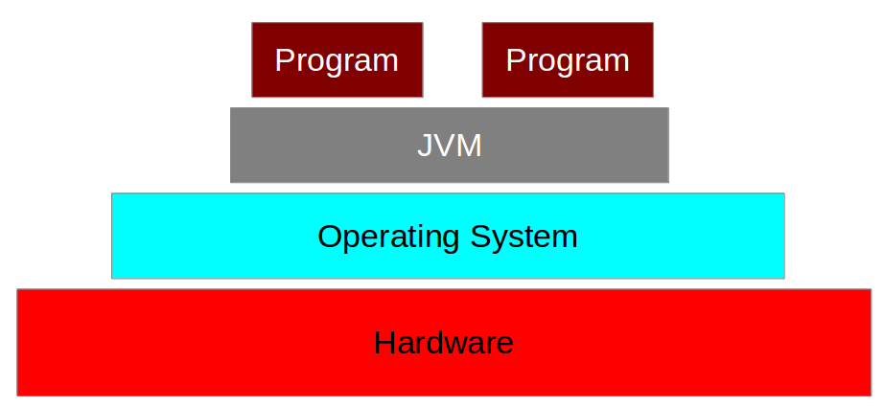

Java programs are compiled by the Java compiler into *bytecode*. The Java virtual machine interprets this *bytecode* and executes the Java program.

[**2.1.2 Java Runtime Environment vs. Java Development Kit**](https://www.vogella.com/tutorials/JavaIntroduction/article.html#java-runtime-environment-vs-java-development-kit)

A Java distribution typically comes in two flavors, the *Java Runtime Environment* (JRE) and the*Java Development Kit* (JDK).

The JRE consists of the JVM and the Java class libraries. Those contain the necessary functionality to start Java programs.

The JDK additionally contains the development tools necessary to create Java programs. The JDK therefore consists of a Java compiler, the Java virtual machine and the Java class libraries

[**2.1.3. Development Process with Java**](https://www.vogella.com/tutorials/JavaIntroduction/article.html#development-process-with-java)

Java source files are written as plain text documents. The programmer typically writes Java source code in an *Integrated Development Environment* (IDE) for programming. An IDE supports the programmer in the task of writing code, e.g., it provides auto-formating of the source code, highlighting of the important keywords, etc.

At some point the programmer (or the IDE) calls the Java compiler ( javac ). The Java compiler creates the *bytecode* instructions. These instructions are stored in .class files and can be executed by the Java Virtual Machine.

**2.1.4.** [**Installation**](https://www.vogella.com/tutorials/JavaIntroduction/article.html#check-installation) **Process**

To run Java programs, you:

* must have the Java runtime environment (JRE) installed
* the Java executables must be available in your path environment

You can test if the JRE is correctly installed via a console. To open a console on Windows: Win+R, enter *cmd* and press Enter).

If the JRE is correctly installed, this commands prints information about your Java installation. In this case you can skip the Java installation description.

If the command line returns the information that the program could not be found, you have to install Java

**2.1.5. Java is one of the most important programming languages in today's IT industries.**

**JSP** - **JSP** technology is used to create web application just like Servlet technology. It can be thought of as an extension to Servlet because it provides more functionality than servlet such as expression language, JSTL, etc.

A JSP page consists of HTML tags and JSP tags. The JSP pages are easier to maintain than Servlet because we can separate designing and development. It provides some additional features such as Expression Language, Custom Tags, etc.

JavaServer Pages (JSP) is a technology for developing Webpages that supports dynamic content. This helps developers insert java code in HTML pages by making use of special JSP tags, most of which start with <% and end with %>.

A JavaServer Pages component is a type of Java servlet that is designed to fulfill the role of a user interface for a Java web application. Web developers write JSPs as text files that combine HTML or XHTML code, XML elements, and embedded JSP actions and commands.

Using JSP, you can collect input from users through Webpage forms, present records from a database or another source, and create Webpages dynamically.

JSP tags can be used for a variety of purposes, such as retrieving information from a database or registering user preferences, accessing JavaBeans components, passing control between pages, and sharing information between requests, pages etc.

* **Applets -** Applets are another type of Java programs that are implemented on Internet browsers and are always run as part of a web document.
* **J2EE -** Java 2 Enterprise Edition is a platform-independent environment that is a set of different protocols and APIs and is used by various organizations to transfer data between each other.
* **Mobile -** In addition to the above technology, Java is widely used in mobile devices nowadays, many types of games and applications are being made in Java.

**JDBC**

Any relational database one can write a single program using the JDBC API, and the JDBC is a Java API for executing SQL Statements(As a point of interest JDBC is trademarked name and is not an acronym; nevertheless ,JDBC is often thought of as standing for Java Database Connectivity. It consists of a set of classes and interfaces written in the Java Programming language .JDBC provides a standard API for tool/database developers and makes it possible to write database applications using a pure Java API.

Using JDBC, it is easy to send SQL statements to virtually program will be able to send SQL .statements to the appropriate database. The Combination of Java and JDBC lets a programmer writes it once and run it anywhere.

The current version of JDBC is 4.3. It is the stable release since 21st September, 2017. It is based on the X/Open SQL Call Level Interface. The **java.sql** package contains classes and interfaces for JDBC API. A list of popular *interfaces* of JDBC API are given below:

* Driver interface
* Connection interface
* Statement interface
* PreparedStatement interface
* CallableStatement interface
* ResultSet interface
* ResultSetMetaData interface
* DatabaseMetaData interface
* RowSet interface

A list of popular *classes* of JDBC API are given below:

* DriverManager class
* Blob class
* Clob class
* Types class

**2.1.6 Types of Java Applications**

* **Web Application** - Java is used to create server-side web applications. Currently, Servlet, JSP, Struts, JSF, etc. technologies are used.
* **Standalone Application -** It is also known as the desktop application or window-based application. An application that we need to install on every machine or server such as media player, antivirus, etc. AWT and Swing are used in java for creating standalone applications.
* **Enterprise Application -** An application that is distributed in nature, such as banking applications, etc. It has the advantage of high-level security, load balancing, and clustering. In Java, EJB is used for creating enterprise applications.
* **Mobile Application -** Java is used to create application software for mobile devices. Currently, Java ME is used for building applications for small devices,

**2.1.7 Features of Java**

* **Object-Oriented -** Java supports the features of object-oriented programming. Its object model is simple and easy to expand.
* **Platform independent -** C and C++ are platform dependency languages hence the application programs written in one Operating system cannot run in any other Operating system, but in platform independence language like Java application programs written in one Operating system can able to run on any Operating system.
* **Simple -** Java has included many features of C / C ++, which makes it easy to understand.
* **Secure -** Java provides a wide range of protection from viruses and malicious programs.  It ensures that there will be no damage and no security will be broken.
* **Portable -** Java provides us with the concept of portability. Running the same program with Java on different platforms is possible.
* **Robust -** During the development of the program, it helps us to find possible mistakes as soon as possible.
* **Multi-threaded -** The multithreading programming feature in Java allows you to write a program that performs several different tasks simultaneously.
* **Distributed -** Java is designed for distributed Internet environments as it manages the TCP/IP protocol.

**2.1.8 Popular Java Editors**

You will need a text editor to write Java programs. There is even more sophisticated IDE available in the market. But for now, you can consider one of the following:

* **Notepad -** On Windows machine, you can use any simple text editor like Notepad (Recommended for this tutorial), Text Pad.
* **Eclipse -** is also a java IDE developed by the Eclipse open source community.
* **Net beans -** is a Java IDE that is open source and free. Net Beans is an Integrated Development Environment (IDE) for developing primarily with [Java](http://en.wikipedia.org/wiki/Java_(programming_language)), but also with other languages, in particular PHP, C/C++, and HTML. It is also an application platform framework for Java desktop applications and others. The Net Beans IDE is written in Java and can run on Windows, OS X, Linux, Solaris and other platforms supporting a compatible JVM. The Net Beans platform allows applications to be developed from a set of modular software components called modules.

The platform offers reusable services common to desktop applications, allowing developers to focus on the logic specific to their application. Among the features of the platform are:

* User interface management (e.g. menus and toolbars)
* User settings management
* Storage management (saving and loading any kind of data)
* Window management
* Wizard framework (supports step-by-step dialogs)
* Net Beans Visual Library
* Integrated development tools

Net Beans IDE is a free, open-source, cross-platform IDE with built-in-support for Java Programming Language. Net Beans IDE is an open-source integrated development environment. Net Beans IDE supports development of all Java application.

In this system **“Institute management Site”** we use Net beans IDE.

**APACHE TOMCAT SERVER-**

Apache Tomcat is an open source Web server tool developed by the Apache Software Foundation (ASF). It is one of many Apache-related open source products used by IT professionals for various tasks and objectives. Tomcat is developed and maintained by an open community of developers under the auspices of the Apache Software Foundation, released under the Apache License 2.0 license, and is open-source software.

Apache Tomcat is a webcontainer which allows to run servlet and JavaServer Pages (JSP) based web applications. Most of the modern Java web frameworks are based on servlets, e.g. JavaServer Faces, Struts, Spring.

Apache Tomcat also provides by default a HTTP connector on port 8080, i.e., Tomcat can also be used as HTTP server. But the performance of Tomcat is not as good as the performance of a designated web server, like the Apache HTTP server. The default port for Tomcat is 8080.

Apache Tomcat allows the implementation of Java Servlets and JavaServer Pages (JSP) to promote an effective Java server environment. Users can also access resources for configuration and use extensible markup language (XML) to configure projects. Successive versions of Apache Tomcat have solved different problems by applying software patches and other solutions. Some experts characterize Apache Tomcat as a product offering a runtime shell for Java Servlets. Users can also set up Java virtual machines (JVM) to configure virtual hosting.

**2.2 Designing**

**2.2.1 HTML-**

HTML or Hyper Text Mark-up Language is the standard mark-up language used to create web pages. HTML is written in the form of HTML elements consisting of tags enclosed in angle brackets. HTML tags most commonly come in pairs like and, although some tags the structure of a website semantically along with presentation, making represent empty elements and so are unpaired. The first tag in a pair is the start tag, and the second tag is the end tag (they are also called opening tags and closing tags). A web browser can read HTML files and compose them into visible or audible web pages. The browser does not display the HTML tags, but uses them to interpret the content of the page. HTML describes it a mark-up language rather than a programming language.

**2.2.2CSS-**

* **CSS** stands for **C**ascading **S**tyle **S**heets
* CSS describes **how HTML elements are to be displayed on screen, paper, or in other media**
* CSS **saves a lot of work**. It can control the layout of multiple web pages all at once
* External stylesheets are stored in **CSS files**

CSS is used to define styles for your web pages, including the design, layout and variations in display for different devices and screen sizes.

**2.2.3Bootstrap-**

* Bootstrap is a free front-end framework for faster and easier web development
* Bootstrap includes HTML and CSS based design templates for typography, forms, buttons, tables, navigation, modals, image carousels and many other, as well as optional JavaScript plugins.
* Bootstrap also gives you the ability to easily create responsive designs.
* Bootstrap was developed by Mark Otto and Jacob Thornton at Twitter, and released as an open source product in August 2011 on GitHub.
* **In June 2014 Bootstrap was the No.1 project on GitHub**

**2.2.4JavaScript-**

JavaScript is one of the **3 languages** all web developers **must** learn:

   1. **HTML** to define the content of web pages

   2. **CSS** to specify the layout of web pages

   3. **JavaScript** to program the behavior of web pages

Web pages are not the only place where JavaScript is used. Many desktop and server programs use JavaScript. Node.js is the best known. Some databases, like MongoDB and CouchDB, also use JavaScript as their programming language.

JavaScript is a very powerful **client-side scripting language**. JavaScript is used mainly for enhancing the interaction of a user with the webpage. In other words, you can make your webpage more lively and interactive, with the help of JavaScript.

**2.3 INTRODUCTION OF MYSQL (Back End)**

MySQL is the most popular Open Source Relational SQL Database Management System. MySQL is one of the best RDBMS being used for developing various web-based software applications. MySQL is developed, marketed and supported by MySQL AB, which is a Swedish company.

**2.3.1 What is a Database?**

A database is a separate application that stores a collection of data. Each database has one or more distinct APIs for creating, accessing, managing, searching and replicating the data it holds.

Other kinds of data stores can also be used, such as files on the file system or large hash tables in memory but data fetching and writing would not be so fast and easy with those type of systems.

Nowadays, we use relational database management systems (RDBMS) to store and manage huge volume of data. This is called relational database because all the data is stored into different tables and relations are established using primary keys or other keys known as **Foreign Keys**.

**2.3.2 MySQL Database**

MySQL is a fast, easy-to-use RDBMS being used for many small and big businesses. MySQL is developed, marketed and supported by MySQL AB, which is a Swedish company. MySQL is becoming so popular because of many good reasons −

* MySQL is released under an open-source license. So you have nothing to pay to use it.
* MySQL is a very powerful program in its own right. It handles a large subset of the functionality of the most expensive and powerful database packages.
* MySQL uses a standard form of the well-known SQL data language.
* MySQL works on many operating systems and with many languages including PHP, PERL, C, C++, JAVA, etc.
* MySQL works very quickly and works well even with large data sets.
* MySQL is very friendly to PHP, the most appreciated language for web development.
* MySQL supports large databases, up to 50 million rows or more in a table. The default file size limit for a table is 4GB, but you can increase this (if your operating system can handle it) to a theoretical limit of 8 million terabytes (TB).
* MySQL is customizable. The open-source GPL license allows programmers to modify the MySQL software to fit their own specific environments

**3. platform specification**

**3.1 SOFTWARE REQUIREMENT**

Operating System  : Windows

Language / Front-end : Java

Data Base/ Back-end : MySQL

Browser : Any

Server : Apache Tomcat

IDE : Netbeans , Eclipse

**3.2 Hardware REQUIREMENT**

Processor : Pentium IV or any other higher versions

Hard Disk : Minimum 2 GB Require

Ram : Minimum 512 MB Require

Display : VGA



**system analysis**

**1.** Objectives of the Project

**2.**Project Organization

**3.**Preliminary Investigation

**1. OBJECTIVES OF THE PROJECT**

* Institute management Site is designed to produce a computerized solution to the manually accessing the Information taking procedure.
* As manually accessing is very long process and it is very time consuming and not effective.
* Online Institute management Site in a less stringent definition may be primarily any direct text-based or video-based [(webcams),](https://en.wikipedia.org/wiki/Webcam) one-on-one chat or one-to-many [group chat](https://en.wikipedia.org/wiki/Chat_room) (formally also known as [synchronousconferencing),](https://en.wikipedia.org/wiki/Synchronous_conferencing) using tools such as [instant messengers,](https://en.wikipedia.org/wiki/Instant_messenger) [Internet Relay Chat](https://en.wikipedia.org/wiki/Internet_Relay_Chat) (IRC), [talkers](https://en.wikipedia.org/wiki/Talker) and possibly [MUDs.](https://en.wikipedia.org/wiki/MUD) The expression online chat comes from the word [chat](https://en.wiktionary.org/wiki/chat) which means "informal conversation".
* Online chat includes [web-based applications](https://en.wikipedia.org/wiki/Web_application) that allow communication – often directly addressed, but anonymous between users in a multi-user environment. [Web conferencing](https://en.wikipedia.org/wiki/Web_conferencing)is a more specific online service, that is often sold as a service, hosted on a web server controlled by the vendor.

**2. PROJECT ORGANIZATION:-**

**2.1 The Incremental Model**

This model is combination of linear sequential model with the iterative concept of prototyping after a specific schedule linear sequential model is repeated. So each increment include a single linear sequential model and first increment provides only core product .This core product is used by student/user and provide a plan for next increment .This plan tells the modification of the core product to better meet the need of the student and the delivery of additional feature and functionality.

* **Analysis:-**

Analysis require the desired information related to our project for requirement analysis, feasibility study etc on the basis of this analysis we prepared the ground for design. The complete analysis is explained in detailed further.

* **Design:-**

Design includes the design of relevant screens, Database and Report etc. related to project which is explained in detailed in the design section. Designs also include the coding portion of project which is given in detail in coding portion.

* **Integration:-**

Actually a project is developed in different modules and finally these modules are integrated to produce the project .For the integration purpose we have designed a MDI form to collect all the form on the same screen.

* **Testing:-**

Testing decides the quality measurement for a project .To design a quality product we are going to apply four testing: Unit testing, System is testing, Integration testing.

* **Deployment:-**

After testing is completed project will be deployed at user’s site. The method used to deploy the project depend on the project depend on the project and nature of.

**3. PRELIMINARY INVESTIGATION:-**

**3.1 IDENTIFICATION OF NEED:-**

1. Review Of Written Method
2. Onsite Observation
3. Interview
4. Questionnaires
5. **Review Of Written Method**

In this fact-finding method, all documentation on data carried is organized and evaluated. The analyst needs find out how they are filled out, how they are easy to user, what changes need to make and how easy they are to be read.

1. **Onsite Observation**

Other fact-finding method used by the system is onsite direct observation .The analyst role is that of information seeker. One purpose of onsite observation is to study the real system. As an observer, is to get close as possible to the real system being studied.

As an observer, the analyst follows sets of rules. The analyst observes the physical layout of the current system, the location and movement of the people, and the workflow.

1. **Interview**

In an interview, since the analyst and the person interview meet face to face, there is an opportunity for greater flexibility in eliciting information. The interviewer is also in a natural position to observe the subjects and the situation to they are responding.

1. **Questionnaires**

This fact-finding method is used when the staff is located over a wide geographical area. The information obtained through the questionnaires is limited to the written response of the subject to predefined questions.



**feasibility study**

1. Feasibility

**1.1** Operational Feasibility

**1.2** Technical Feasibility

**1.3** Economical Feasibility

1. **FEASIBILITY**

**Feasibility** is the measure of how beneficial or practical the development of an information system will be to an organization. Unfortunately, development of a computer-based system is plagued by scarcity of resources, and limited time constraints.

**Feasibility analysis** is the process by which feasibility is measured. The Feasibility analysis in a project that is feasible at one point in time may become infeasible at a later point in time. These identify specific times during the life cycle when feasibility is reevaluated and management review should be conducted at the end of the prior phase. A project can be canceled or revised in scope, schedule, or budget at any of these checkpoints.

Most analysts agree that there are three categories of feasibility test.

* Economic
* Technical
* Behavioral
  1. **ECONOMIC FEASIBILITY:-**

This feasibility is the measure of the cost effectiveness of a project or solution. This is often called a cost-benefit analysis

There must have sufficient benefits in creating the system to make the cost acceptable. A **“Institute management Site”** can be developed technically and that will be used if installed must still be a good investment for the organization. Financial benefits must equal or exceed the costs. The financial and economic questions raised by analyst during the preliminary investigation are for the purpose of estimating the following:-

* The cost to conduct a full system investigation.
* The cost of hardware and software.
* The cost if nothing changes.
* The cost can also be calculated on the basis of Line of Code (LOC).

**1.2 TECHNICAL FEASIBILITY**

This feasibility is the measure of the practicality of a specific technical solution and the availability of the technical resources and expertise.

Technical feasibility focuses on the existing computer hardware and software, as to what extent it can support the proposed system. It deals with the availability of the required technology for implementing the proposed system. The ***“Institute management Site”*** is developed in windows environment using JSP(Java Server Pages),Java (JDK 1.6), Net beans IDE 7.1 , and MYSQL , Apache Tomcat.

**1.3 BEHAVIORAL FEASIBILITY**

This is the measure of how well the solution will work in the organization. It is also a measure if how people feel about the system/project.

The ***“Institute management Site”*** system follows Behavioral Feasibility because of its friendliness in nature. Anyone can operate easily, for this we have developed user interface and user friendly system. We have provided maximum information and instruction to the user going to use the system.



**Requirement**

**analysis**

1. Existing System
2. Proposed System

**1. EXISTING SYSTEM:**

* This existing system is not providing secure registration and profile management of all the users properly.
* This manual system gives us very less security for saving data and some data may be lost due to mismanagement.
* In the previous management system all the details required were taken manually in the form of documents. In this system every individual had to stand in a queue which involved individuals in huge numbers.

**2. PROPOSED SYSTEM:**

Institute management Site is a question and answer site. Students ask the question and expert will answer the Question. If student ask the irrelevant question, admin can block the student based on incident report. If expert will answer irrelevant, admin can also block the expert based on incident report. Student can see unanswered and answered list. Expert will show the list of questions asked in the category he/she is assigned to. Admin can view list of all questions asked by Students and answers provided by Experts as per categories. Admin can view list of all Students and Experts registered with the website. Student and expert can update their profile.

In future chat option with the student on a paid basis. Discussion option for the question on a paid basis and rating option.



**SYSTEM design**

1. System Design
   1. DFD Diagram
   2. E-R Diagram
2. UML View
   1. Use Case Diagram
   2. Activity Diagram
   3. Class Diagram

**2.4** Sequence Diagram

1. Database Description

**1. SYSTEM DESIGN**

System design is the process of defining the elements of a system such as the architecture, modules and components, the different interfaces of those components and the data that goes through that system. It is meant to satisfy specific needs and requirements of a business or organization through the engineering of a coherent and well-running system. Systems design is the process of defining the architecture, components, modules, interfaces, and data for a system to satisfy specified requirements. Systems design could be seen as the application of systems theory to product development. System design in terms of software engineering has its own value and importance in the system development process as a whole. To mention it may though seem as simple as anything or simply the design of systems, button a broader sense it implies a systematic and rigorous approach to design such a system which fulfills all the practical aspects including flexibility, efficiency and security.

**1.1 DATA FLOW DIAGRAM(DFD)**

As information moves through software, it is modified by a series of transformation. A data flow diagram is a graphical representation that depicts information flow and the transforms that are applied as data move from input to output. The basic form of a data flow diagram, also known as a data flow graph or a bubble.

The data flow diagram may be used to represent a system or software at any level of abstraction. In fact, DFDs may be partitioned into levels that represent increasing information flow and functional detail. Therefore, the DFD provides a mechanism for functional modeling as well as information flow modeling.

## 1.1.1 Data Flow Diagrams Notations

* **Process:**Any process that changes the data, producing an output. It might perform computations, or sort data based on logic, or direct the data flow based on business rules.
* **Data store:** Files or repositories that hold information for later use, such as a database table or a membership form.
* **Dataflow:** Dataflow are pipelines through which packets of information flow. Label the arrows with the name of the data that moves through it.
* **External Entity:** External entities are objects outside the system, with which the system communicates. External entities are sources and destinations of the system's inputs and outputs.

Following symbols are used for process, entity, database and dataflow.

External Entity

Process

Data Store

Data Flow

## 1.1.2 Data Flow Diagram Levels

* **Context Diagram**

A context diagram is a top level (also known as "Level 0") data flow diagram. It only contains one process node ("Process 0") that generalizes the function of the entire system in relationship to external entities.

* **DFD Layers**

Draw data flow diagrams can be made in several nested layers. A single process node on a high level diagram can be expanded to show a more detailed data flow diagram. Draw the context diagram first, followed by various layers of data flow diagrams.

* **DFD Levels**

The first level DFD shows the main processes within the system. Each of these processes can be broken into further processes until you reach pseudo code.

**0-level DFD Diagram**

The following figure 4.1 shows the 0-Level Data flow diagram for Institute management Site. As shows in the Diagram Student, Expert and Admin are entities

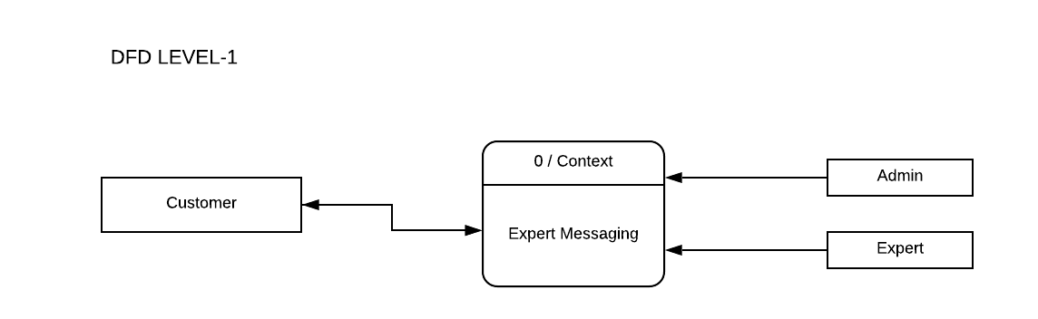

**1- Level DFD Diagram**

The following figure 4.2 shows the 0-Level Data flow diagram for Exper Messaging System. As shows in the Diagram Student, Expert and Admin are entities

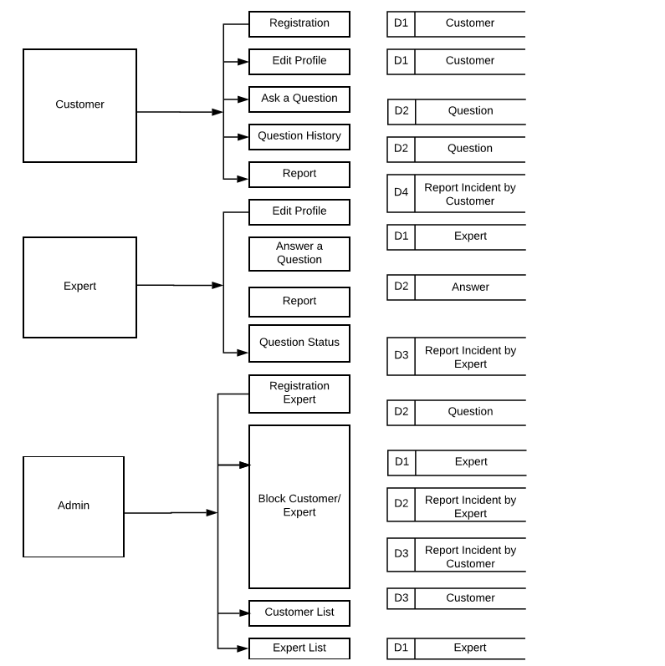

**2- Level DFD Diagram**

* **Student Registration :-**

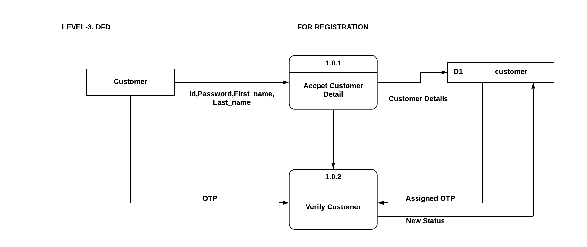

* **Question History :-**

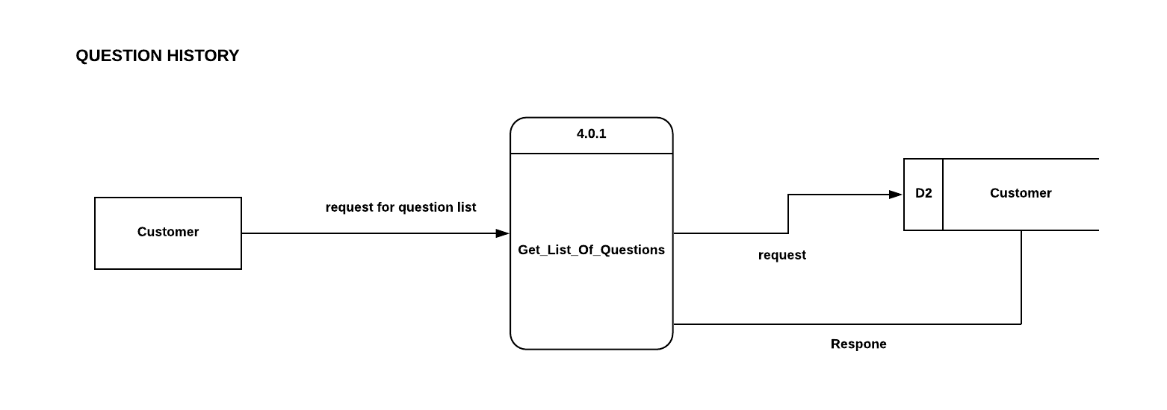

* **Ask A Question :-**

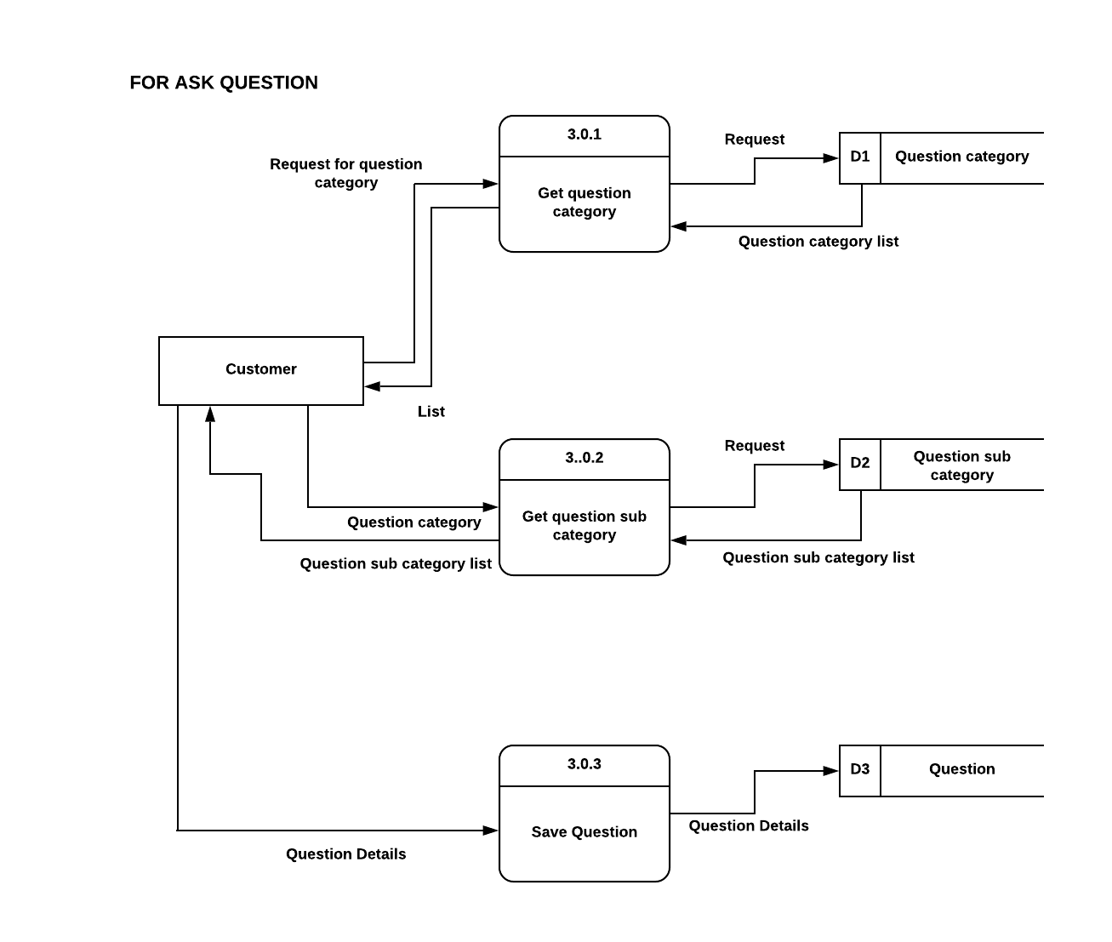

* 1. **E-R DIAGRAM**

**What is the ER Model?**

The ER or (Entity Relational Model) is a high-level conceptual data model diagram. Entity-Relation model is based on the notion of real-world entities and the relationship between them.

Entity Relationship Diagrams are a major data-modeling tool and help organize the data in the project into entities and define the relationships between the entities. This process has proved to enable the analyst to produce a good database structure so that the data can be stored and retrieved in a most efficient manner. An entity-relationship (ER) diagram is a specialized graphic that illustrates the interrelationships between entities in a database. ER diagrams often use symbols to represent three different types of information. Boxes are commonly used to represent entities. Diamonds are normally used to represent relationships and ovals are used to represent attributes.

**Components of the ER Diagram**

This model is based on three basic concepts:

* Entities
* Attributes
* Relationships

#### Entity -

An entity can be a person, place, event, or object that is relevant to a given system. For example, a school system may include students, teachers, major courses, subjects, fees, and other items. Entities are represented in ER diagrams by a rectangle and named using singular nouns.

#### Entity set:

#### An entity set is a group of similar kind of entities. It may contain entities with attribute sharing similar values.

#### Types of Entities

* Strong Entity
* Weak Entity

#### Attribute -

An attribute is a property, trait, or characteristic of an entity, relationship, or another attribute. For example, the attribute Inventory Item Name is an attribute of the entity Inventory Item. An entity can have as many attributes as necessary. Meanwhile, attributes can also have their own specific attributes. For example, the attribute “student address” can have the attributes number, street, city, and state. These are called composite attributes. Note that some top level ER diagrams do not show attributes for the sake of simplicity. In those that do, however, attributes are represented by oval shapes.

#### Types of Attributes

* Simple attribute
* Composite attribute
* Derived attribute

**Relationship –:**  A relationship describes how entities interact.

**Types of Relationships**

* One-to-One Relationships
* One-to-Many Relationships
* May to One Relationships
* Many-to-Many Relationships

**Symbols of ER Diagram**

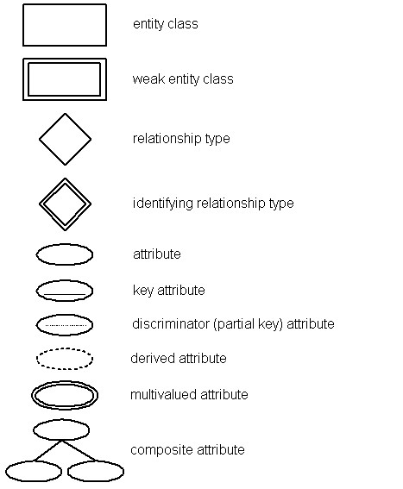

The following figure shows ER- diagram for **“Institute management Site”**.

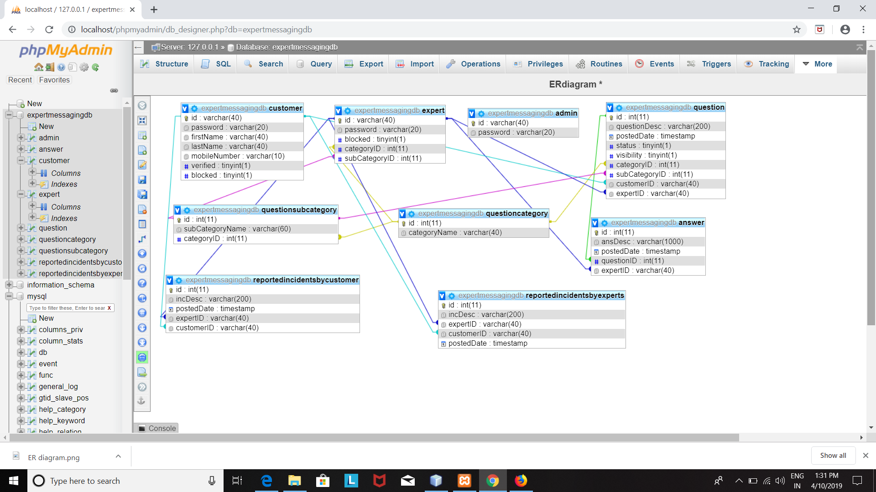

**Fig:- Entity Relationship Diagram**

**2.UML View**

UML is an acronym that stands for Unified Modeling Language**.** Simply put, UML is a modern approach to modeling and documenting software. In fact, it’s one of the most popular business process modeling techniques.It is based on diagrammatic representations of software components. As the old proverb says “a picture is worth a thousand words”. By using visual representations, we are able to better understand possible flaws or errors in software or business processes.UML was created as a result of the chaos revolving around software development and documentation. In the 1990s, there were several different ways to represent and document software systems. The need arose for a more unified way to visually represent those systems and as a result, in 1994-1996, the UML was developed by three software engineers working at Rational Software. It was later adopted as the standard in 1997 and has remained the standard ever since, receiving only a few updates.

We prepare UML diagrams to understand the system in a better and simple way. A single diagram is not enough to cover all the aspects of the system. UML defines various kinds of diagrams to cover most of the aspects of a system.

You can also create your own set of diagrams to meet your requirements. Diagrams are generally made in an incremental and iterative way.

There are two broad categories of diagrams and they are again divided into subcategories −

* Structural Diagrams
* Behavioral Diagrams

**Structural UML diagrams**

* Class diagram
* Package diagram
* Object diagram
* Component diagram
* Composite structure diagram
* Deployment diagram

**Behavioral UML diagrams**

* Activity diagram
* Sequence diagram
* Use case diagram
* State diagram
* Communication diagram
* Interaction overview diagram
* Timing diagram

**2.1 USE CASE DIAGRAM-**

Use case diagrams are a set of use cases, actors, and their relationships. They represent the use case view of a system.

A use case represents a particular functionality of a system. Hence, use case diagram is used to describe the relationships among the functionalities and their internal/external controllers. These controllers are known as **actors**.

## 2.1.1 Use Case Diagram Notations

* Actor
* Use Case
* Relationship
* System Boundary

### Actor:

Actors are usually individuals involved with the system defined according to their roles. The actor can be a human or other external system.

### Use Case:

A use case describes how actors use a system to accomplish a particular goal. Use cases are typically initiated by a user to fulfill goals describing the activities and variants involved in attaining the goal.

### Relationship:

The relationships between the actors and the use cases.

### System Boundary:

The system boundary defines the system of interest in relation to the world around it.

## 2.1.2 How to Draw a Use Case Diagram

A Use Case model can be developed by following the steps below.

* Identify the Actors (role of users) of the system.
* For each category of users, identify all roles played by the users relevant to the system.
* Identify what are the users required the system to be performed to achieve these goals.
* Create use cases for every goal.
* Structure the use cases.

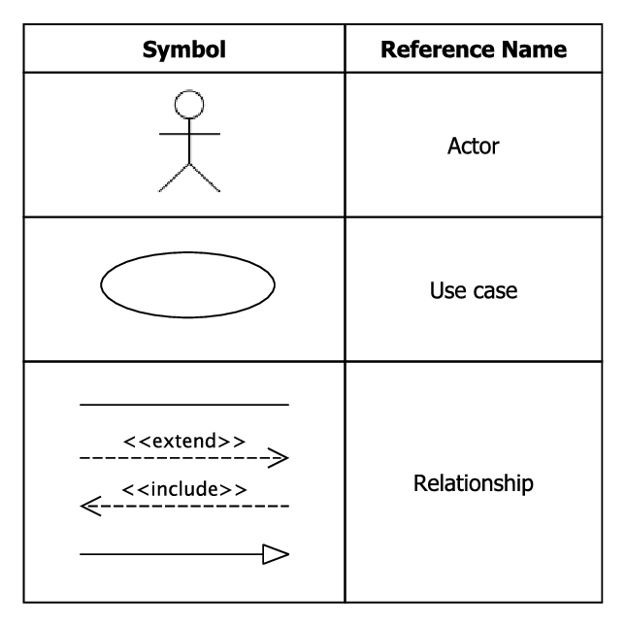

**UML(Use Case Diagram)-**

1. **Student**

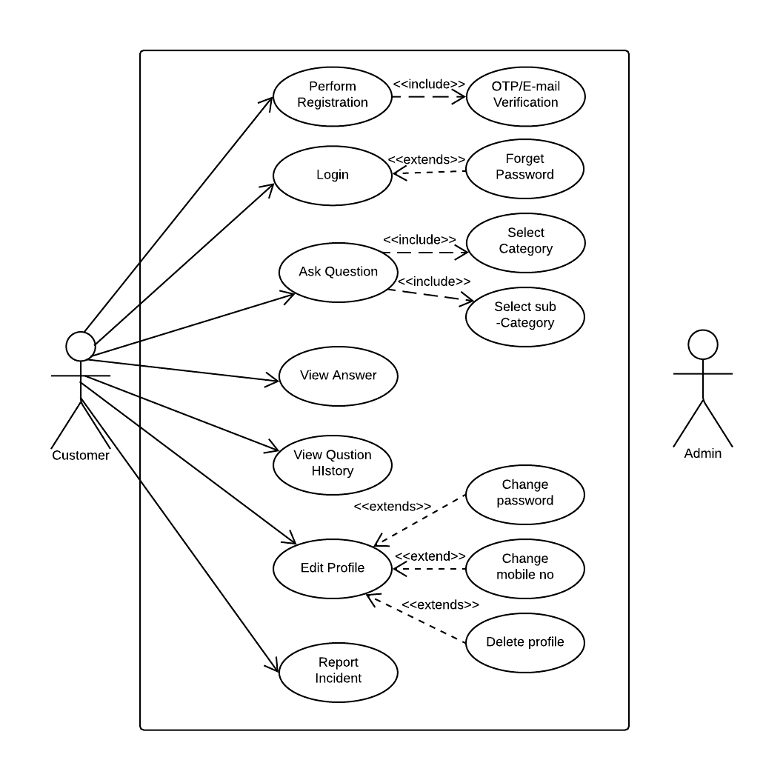

1. **Expert & Admin**

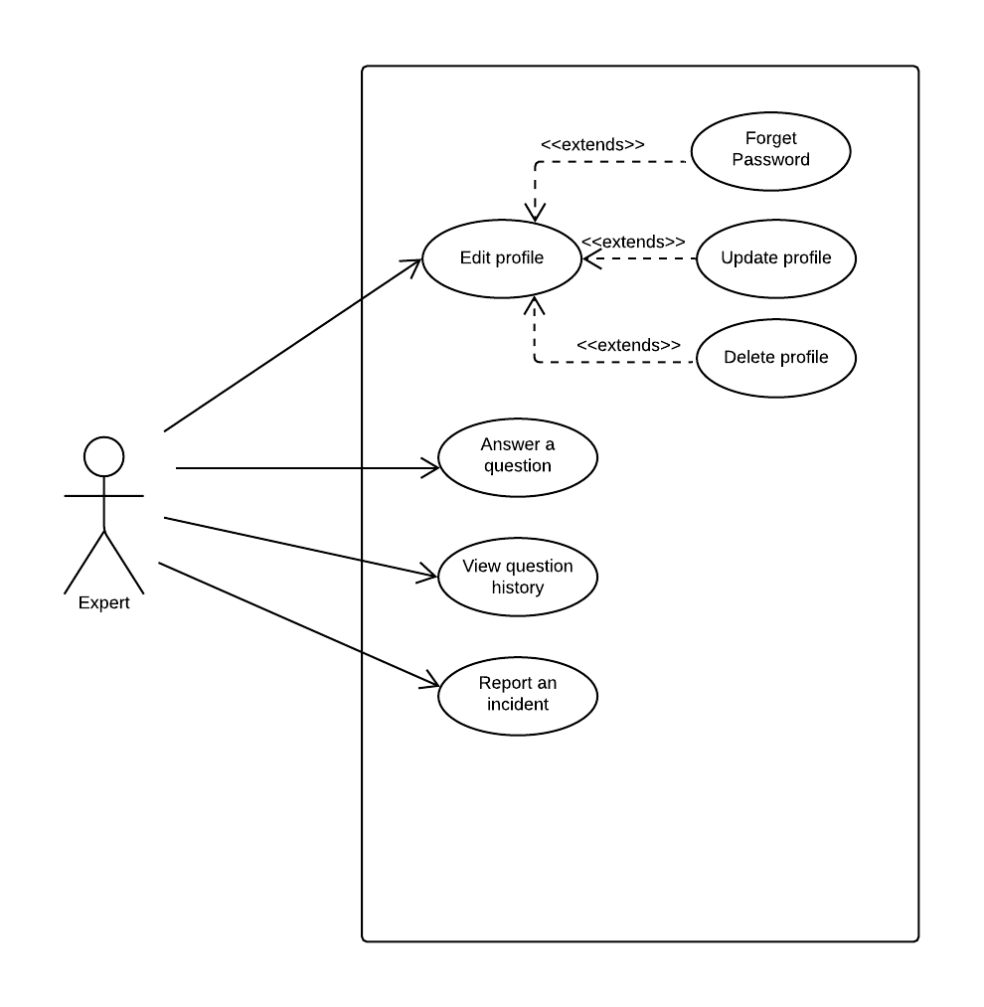

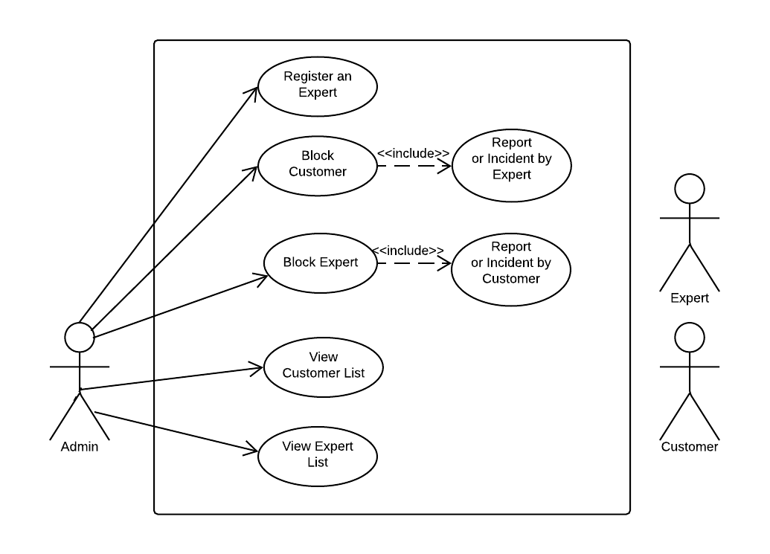

**2.2 ACTIVITY DIAGRAM**

Activity diagram describes the flow of control in a system. It consists of activities and links. The flow can be sequential, concurrent, or branched.

Activities are nothing but the functions of a system. Numbers of activity diagrams are prepared to capture the entire flow in a system.

Activity diagrams are used to visualize the flow of controls in a system. This is prepared to have an idea of how the system will work when executed.

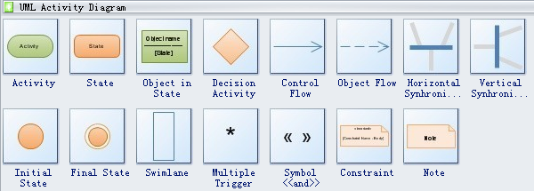

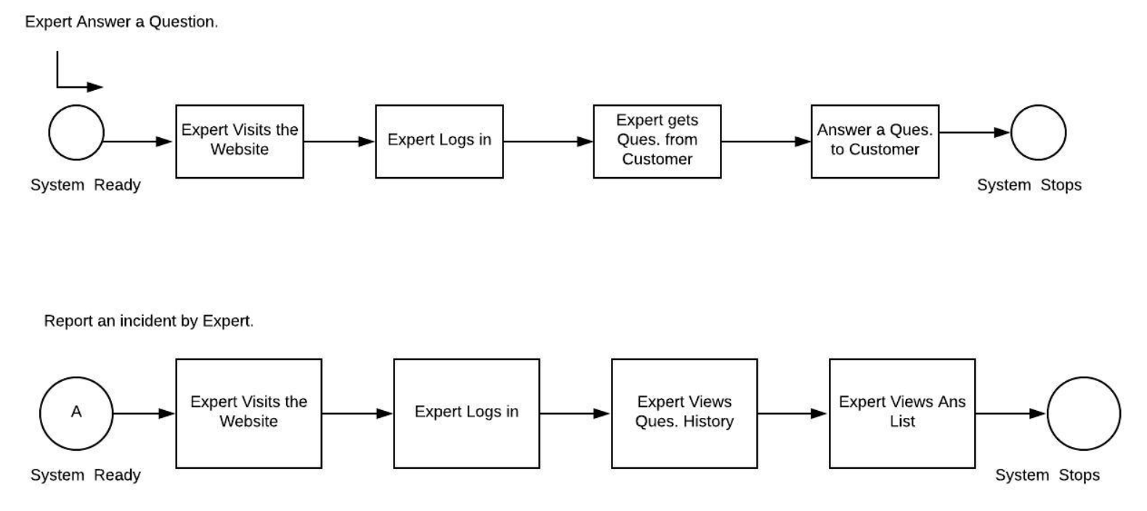**Expert Answer A Question**

**Expert Edit Profile**

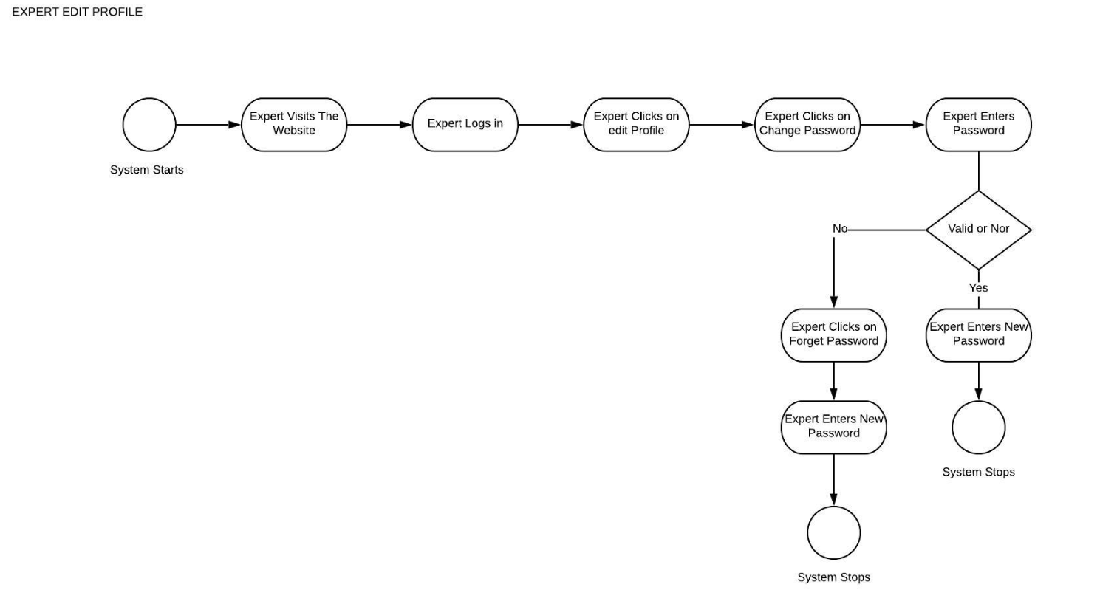

**Report an incident By expert**



**1.3.3 CLASS DIAGRAM**

Class diagrams are the most common diagrams used in UML. Class diagram consists of classes, interfaces, associations, and collaboration. Class diagrams basically represent the object-oriented view of a system, which is static in nature.

Active class is used in a class diagram to represent the concurrency of the system.

Class diagram represents the object orientation of a system. Hence, it is generally used for development purpose. This is the most widely used diagram at the time of system construction.

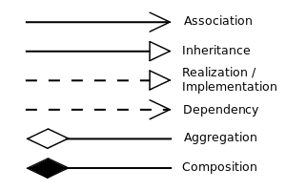

**CLASS DIAGRAM FOR “INSTITUTE MANAGEMENT SITE”**

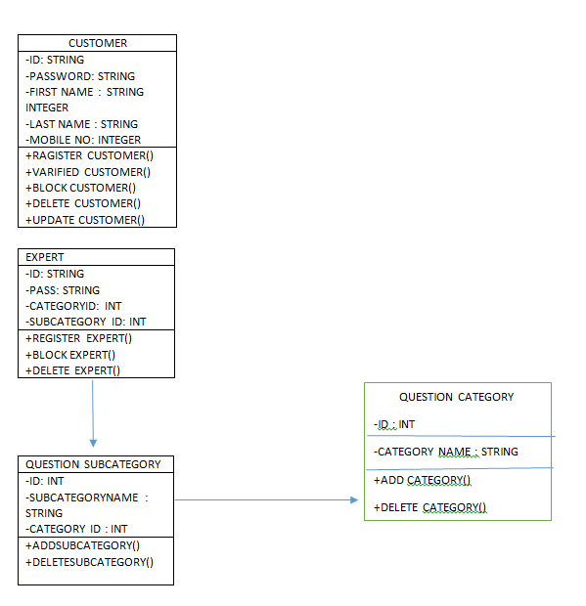

ANSWER TABLE

-ID: STRING

-DESC: STRING

-QUESTION ID : STRING

-EXPERT ID: STRING

+

QUESTION TABLE

-ID: STRING

-DESC: STRING

-CATEGORY ID: INT

-SUB CATEGORY ID : INT

-STUDENT ID : STRING

-EXPERT ID : STRING

+ADD CATEGORY()

+DELETE CATEGORY()

+ADDSUBCATEGORY

+DELETE SUBCATEGORY

EXPERT

-ID: STRING

-PASS: STRING

-CATEGORY ID: INT

-SUB CATEGORY ID: INT

+REGISTER EXPERT()

+BLOCK EXPERT()

+DELETE EXPERT()

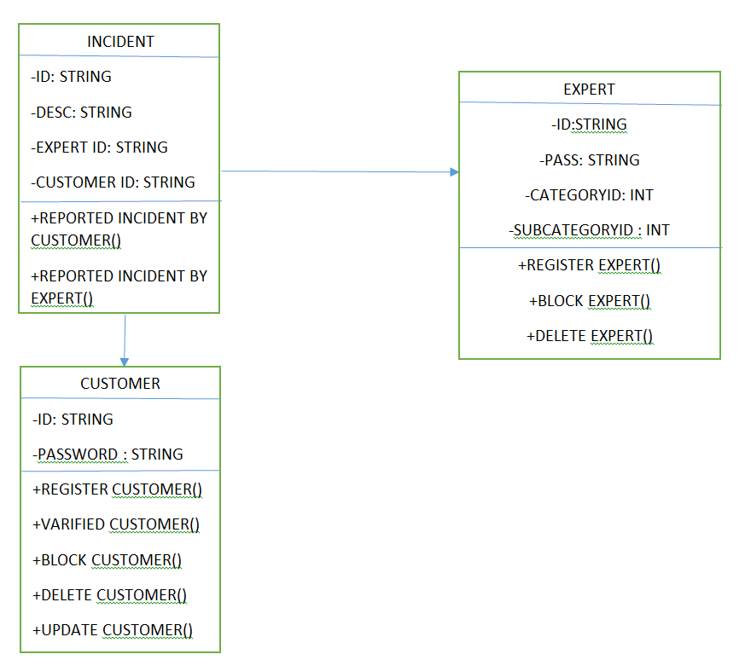

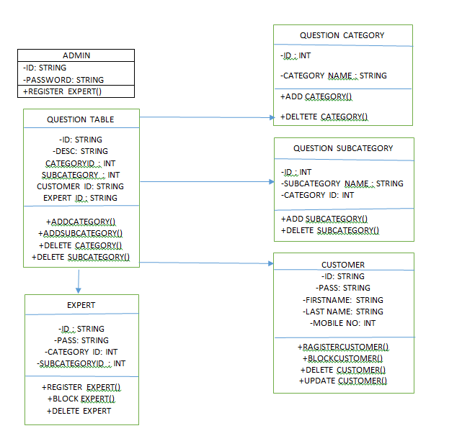

**1.3.4 SEQUENCE DIAGRAM**

A sequence diagram is an interaction diagram. From the name, it is clear that the diagram deals with some sequences, which are the sequence of messages flowing from one object to another.

Interaction among the components of a system is very important from implementation and execution perspective. Sequence diagram is used to visualize the sequence of calls in a system to perform a specific functionality.

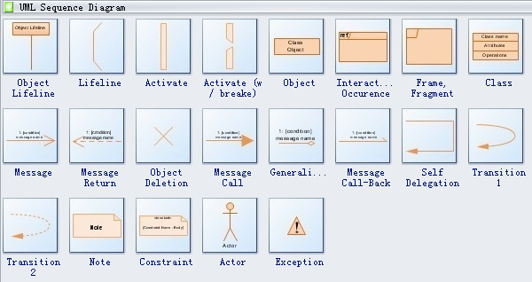

* **Admin Block Expert-**

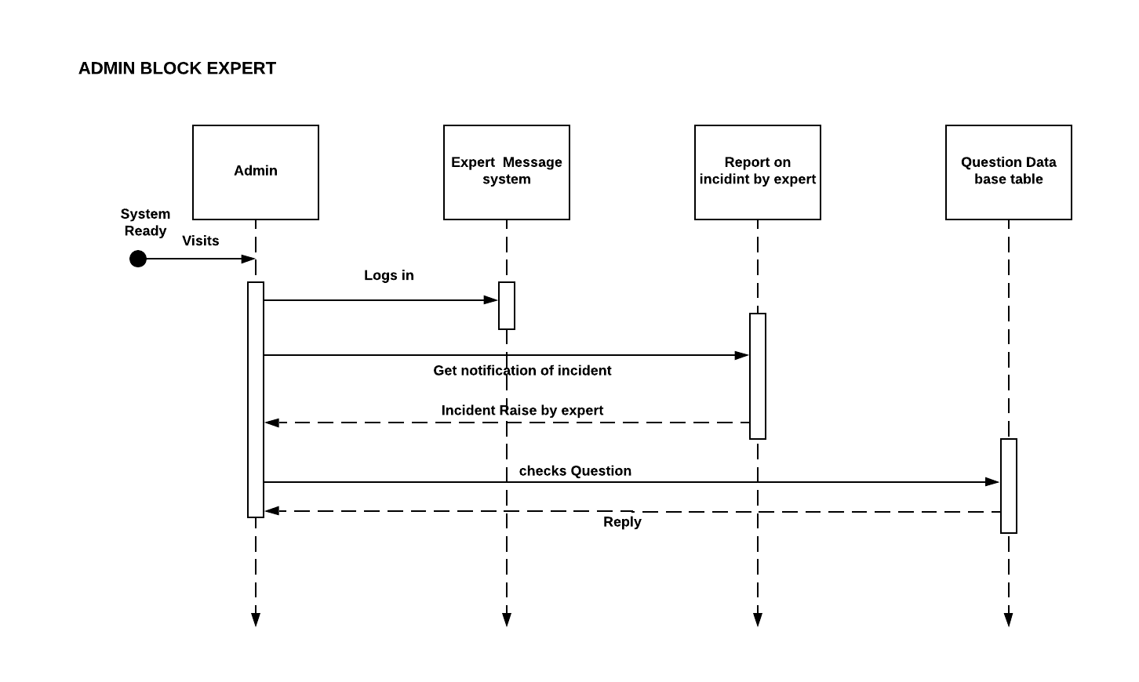

* **Expert Answer A Question-**

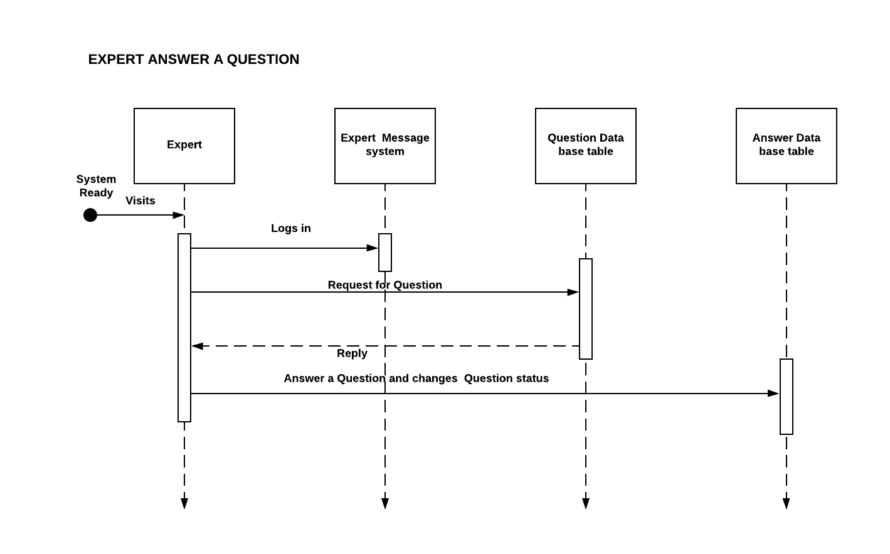

* **Question History-**

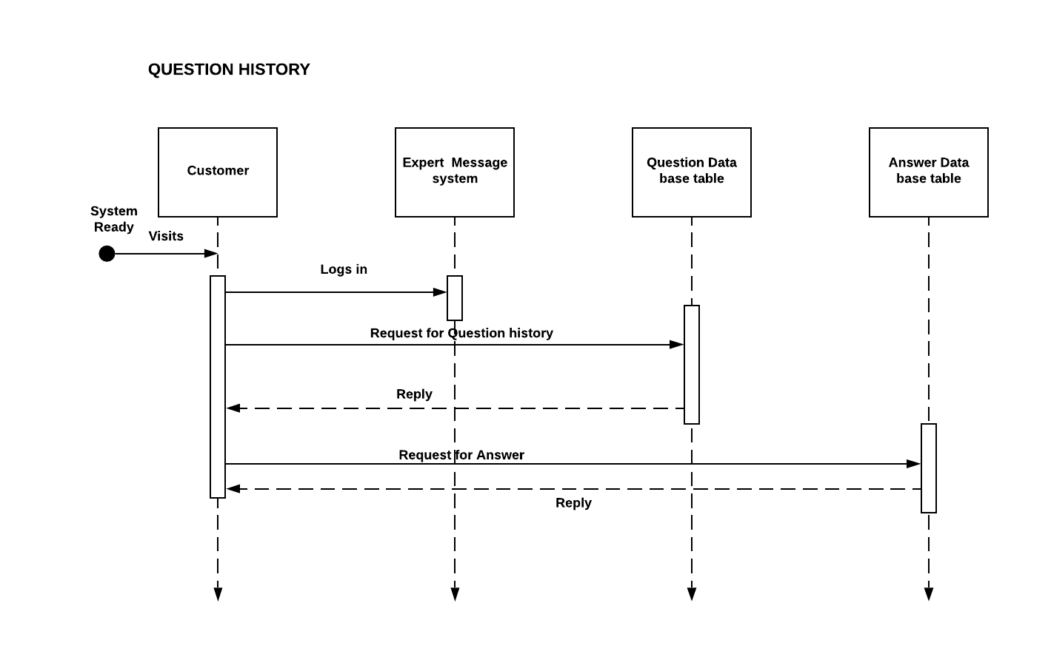

* **Report An Incident By Student-**

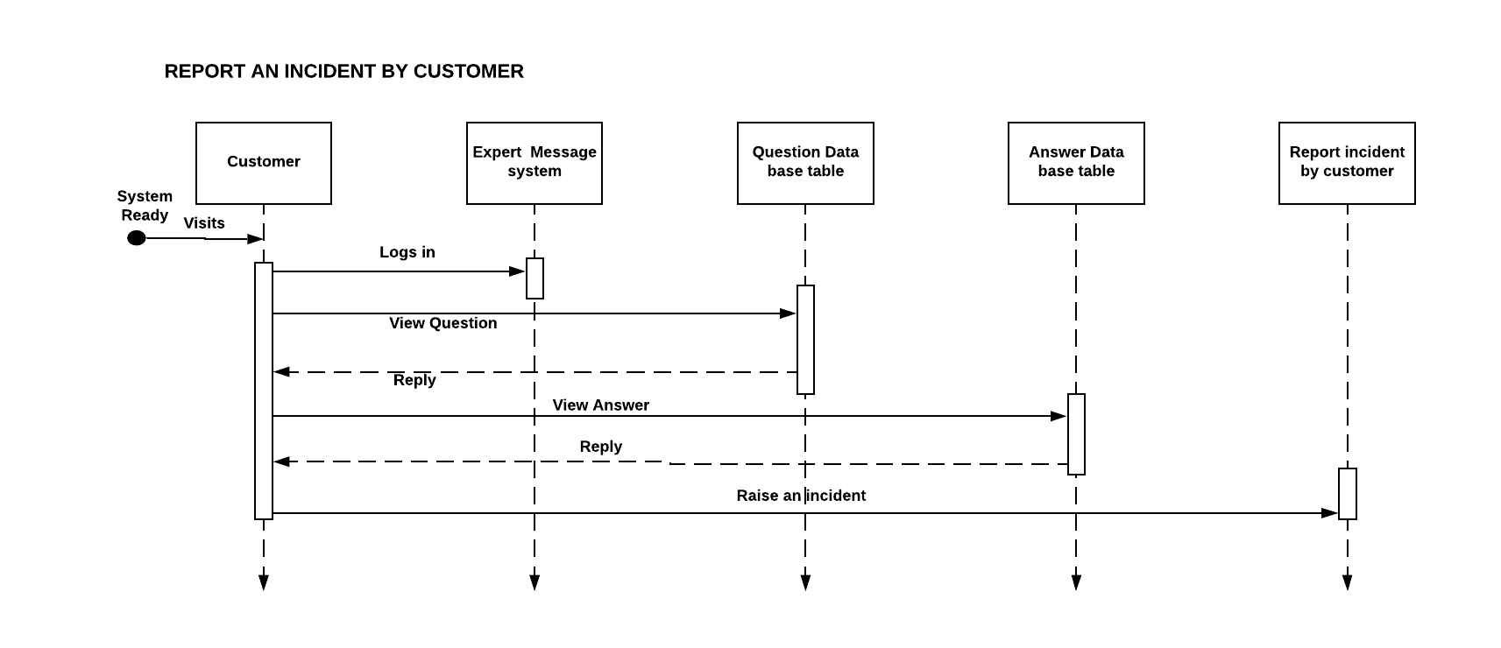

* **Student Registration**

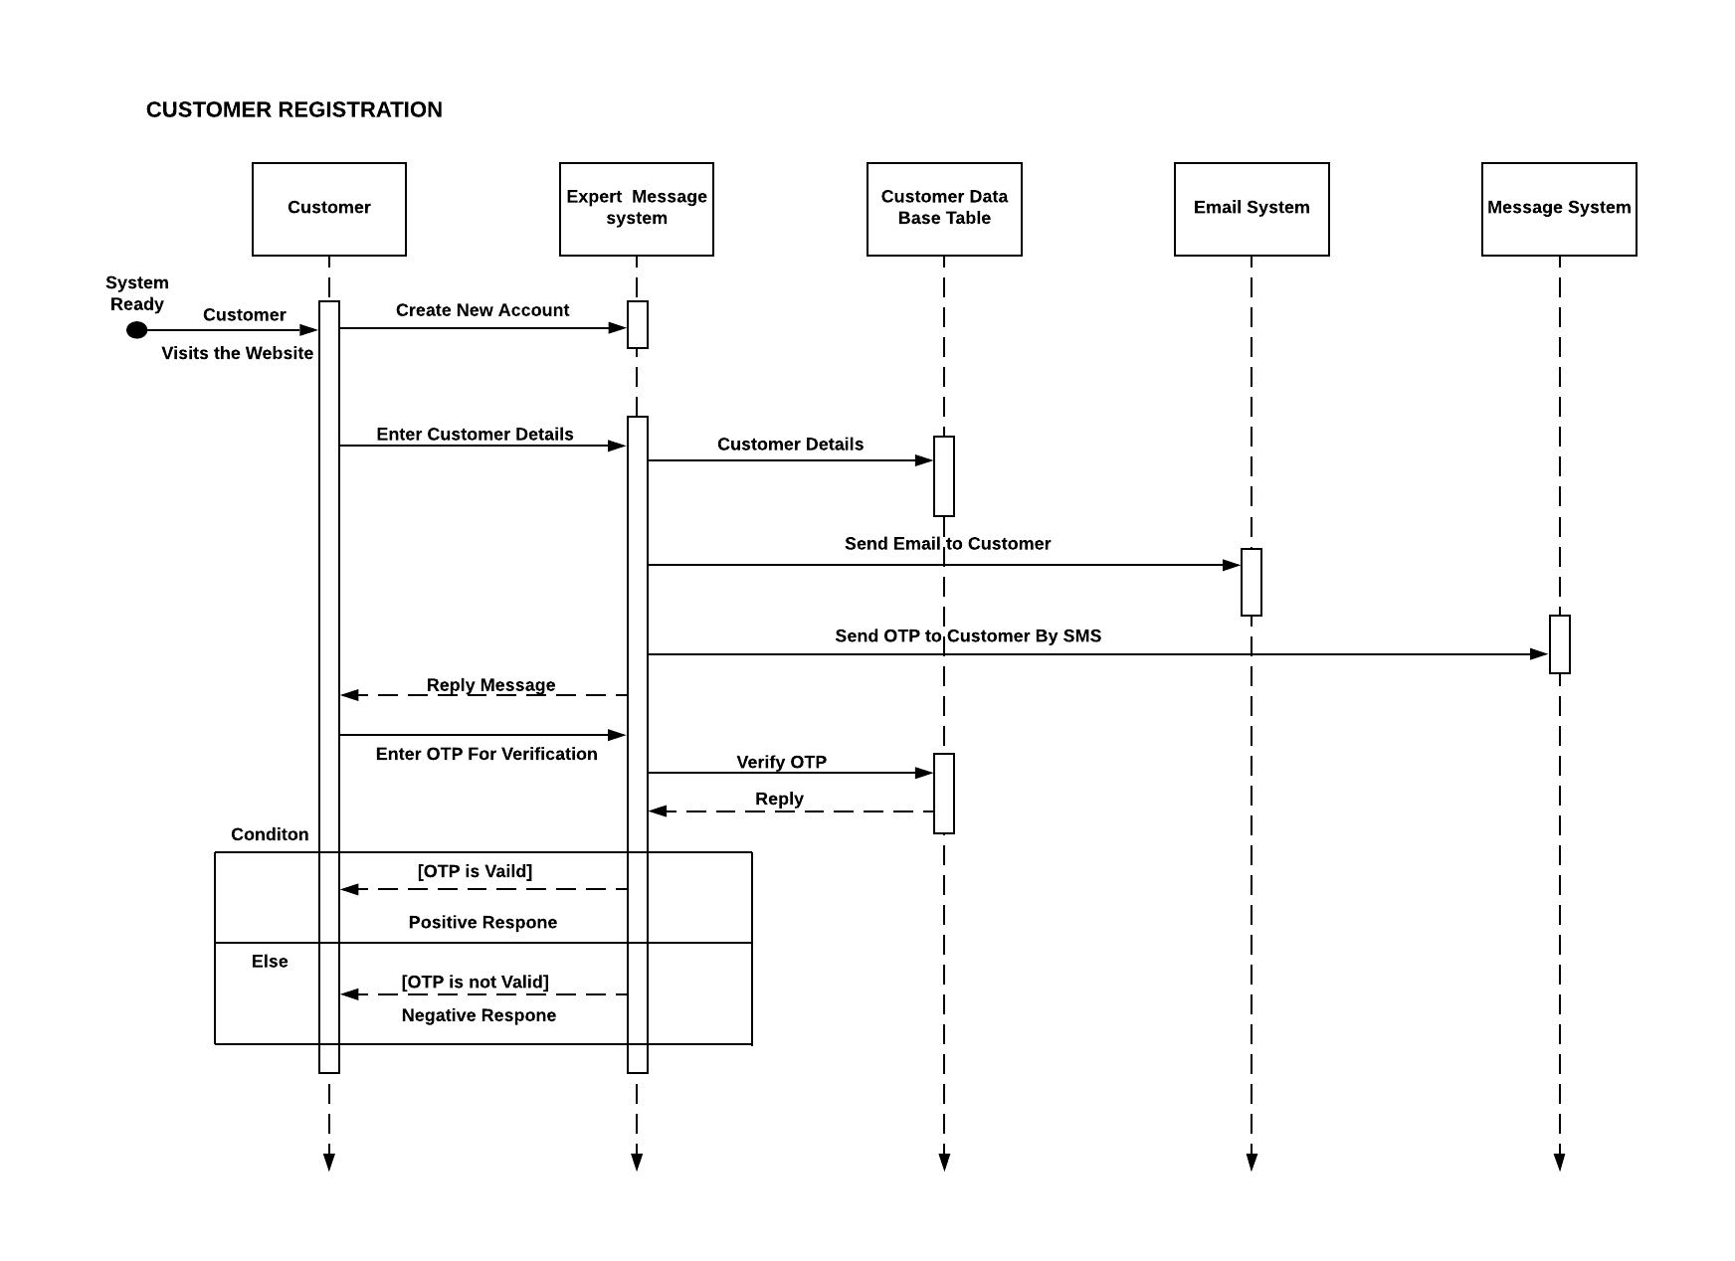

* **Student Ask A Question**

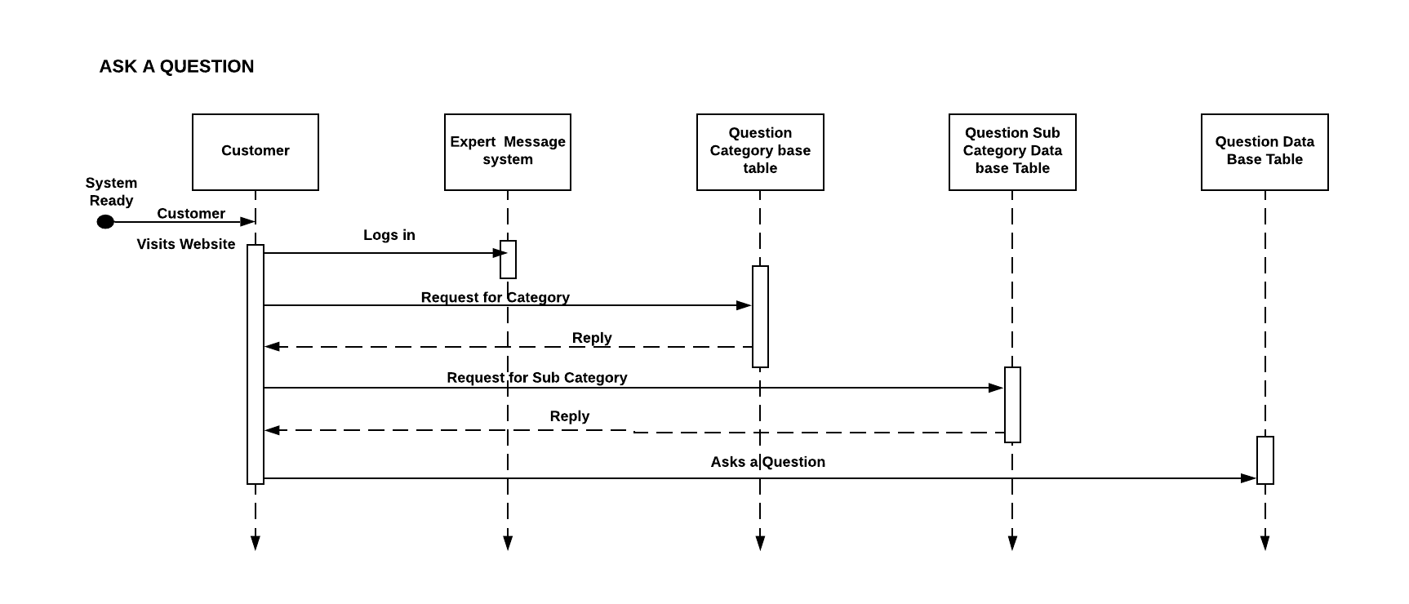

1. **DATABASE DESCRIPTION**

Our database will be centralized database that run on Phpmyadmin Server. There are various kind of tables are used for different-different purpose. The database will give you the complete structure of the Data Structure. The database will act as a back-end of the software.

To keep record without any redundancy each entity is represented by an independent table in the database.

PHP My Admin is a free and open source administration tool for MySQL and MariaDB. As a portable web application written primarily in PHP, it has become one of the most popular MySQL administration tools, especially for web hosting service.

In this system**“Institute management Site”**there are total number of tables is nine, that are described below-

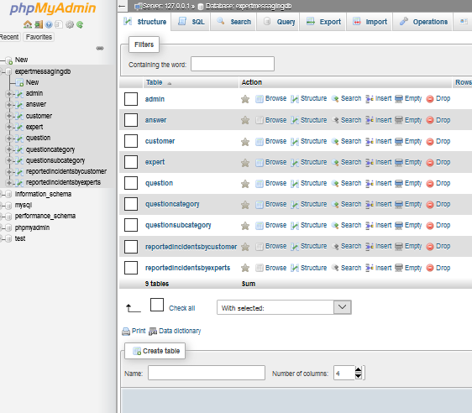

* **Student Table**

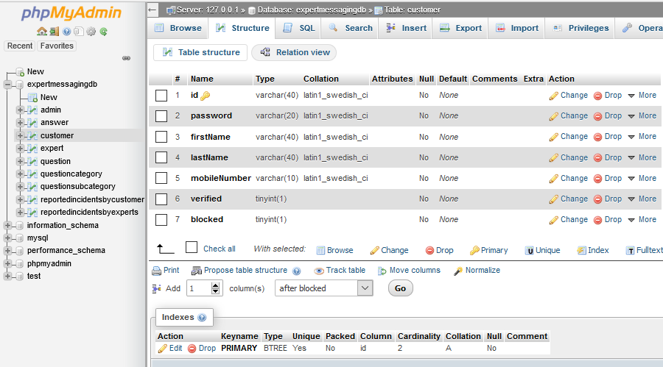

* **Admin Table**

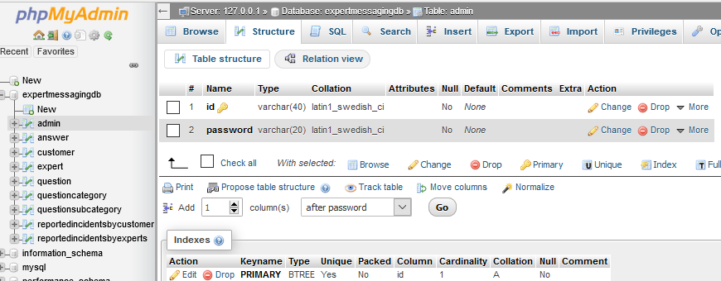

* **Expert Table**

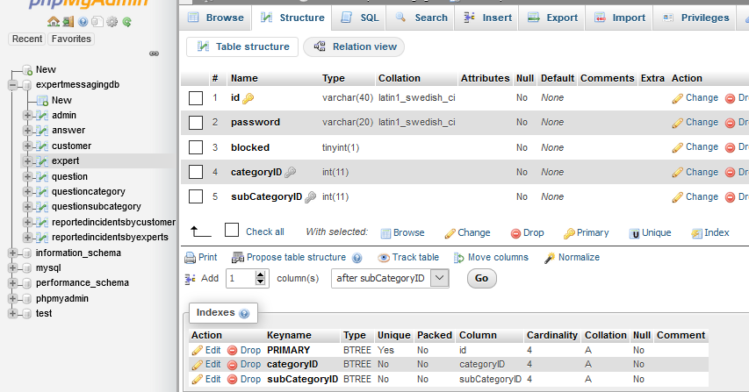

* **Question category Table**

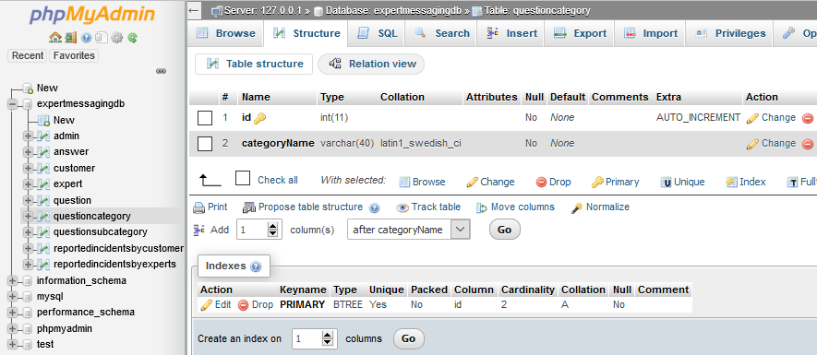

* **Question subcategory Table**

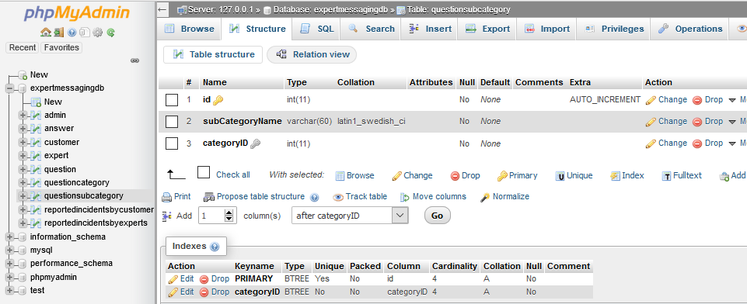

* **Question Table**

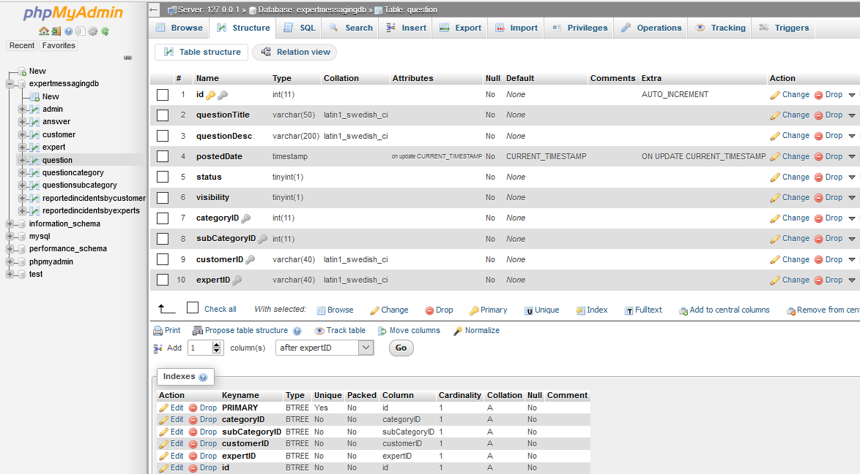

* **Answer Table**

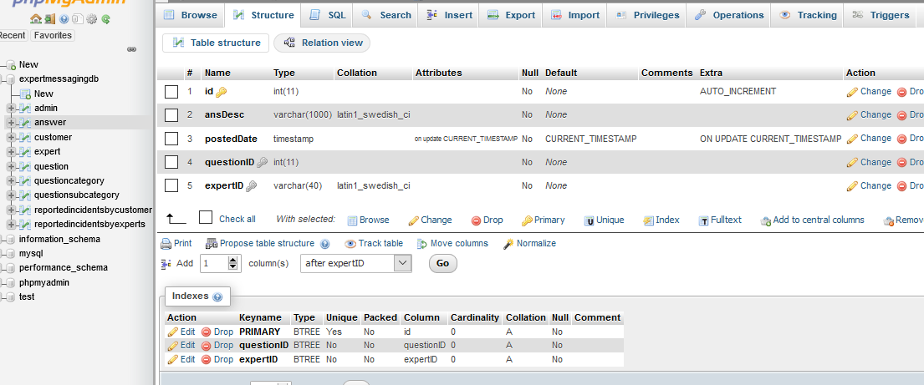

* **Report An Incident By Student**

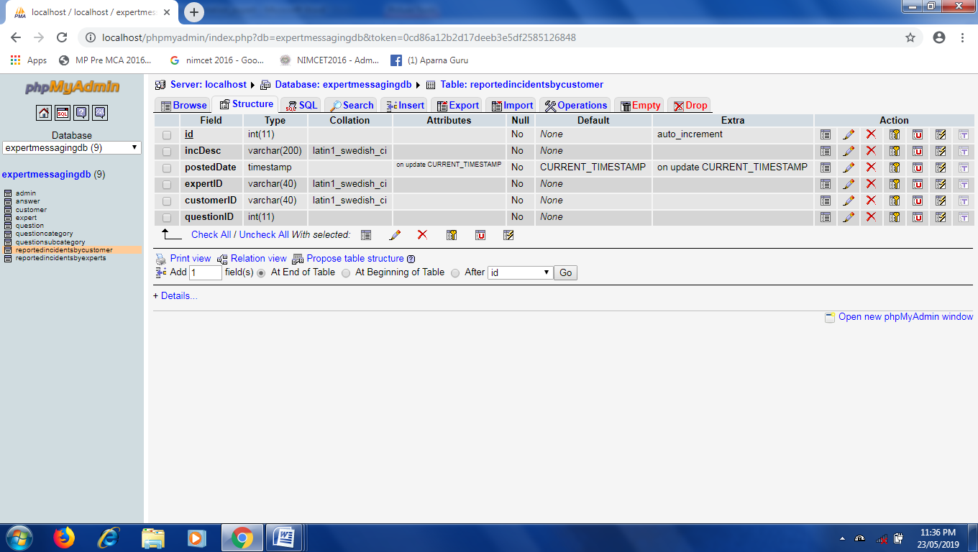

* **Report An Incident By Student**

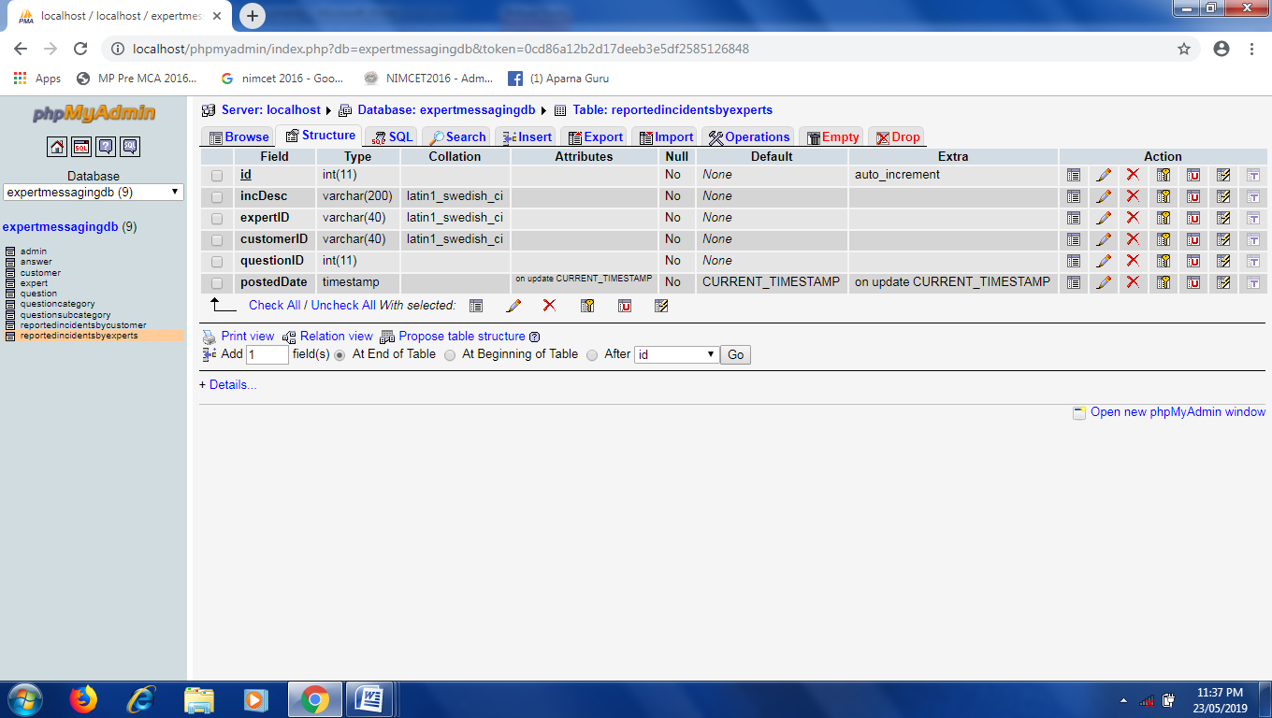



**INPUt OUTPUT**

**SCREEN**

1. **Main Screen -**The main screen contains several options/shortcuts to perform various operations.

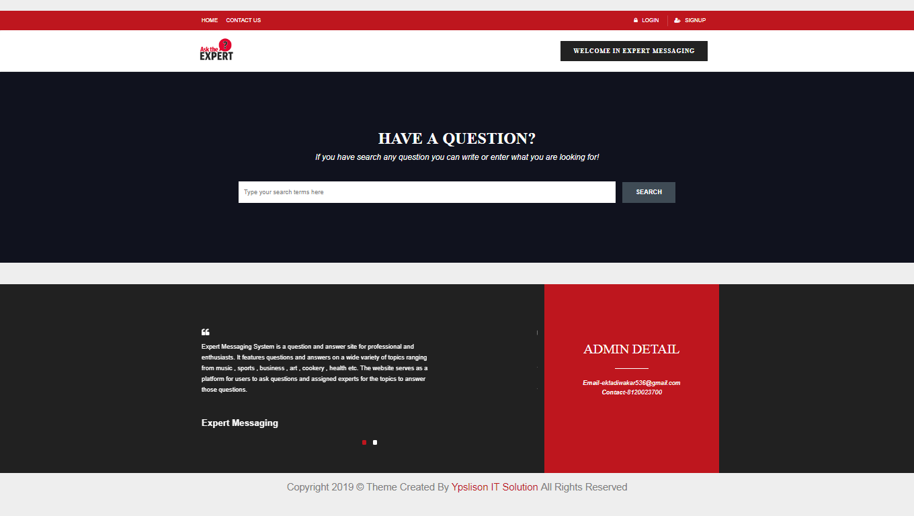

**2. Student Registration-**This screen is display when we click on “Signup” button. Users have to fill all information related to him/her and then click on “Create Account”button. If it has an already account then click on “Already Register Sign in” link and go to login page.

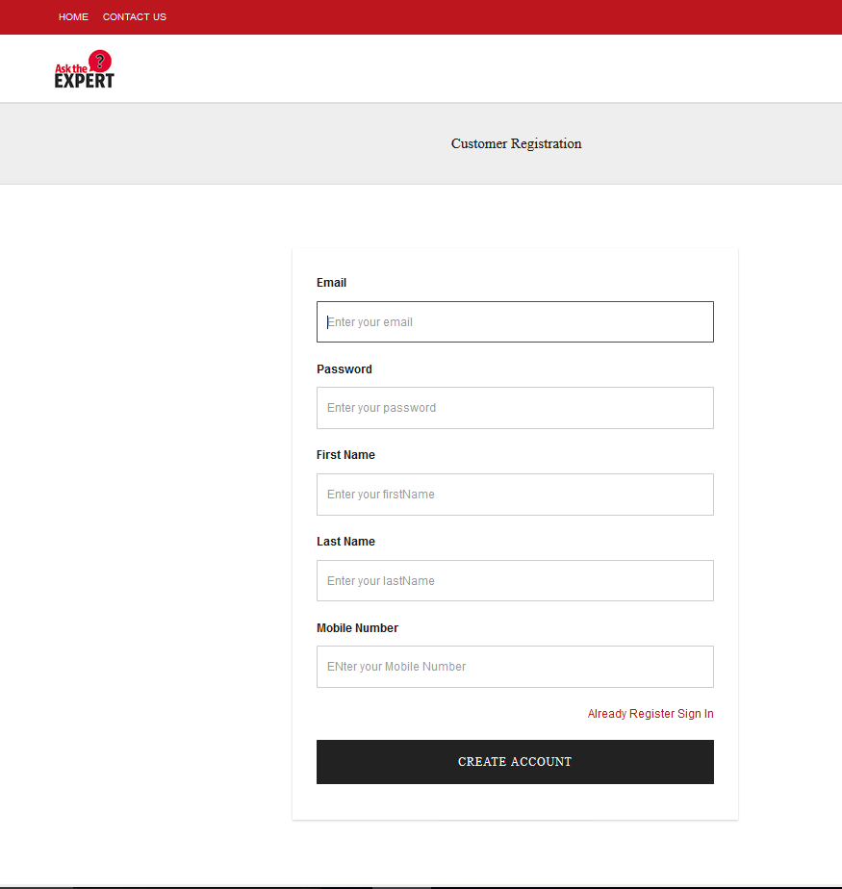

**3. Verification Message For Registration And Gmail Link -** In this screen verification message is show when the successfully registration of student is done and also link of mail is available for student to verify your account.

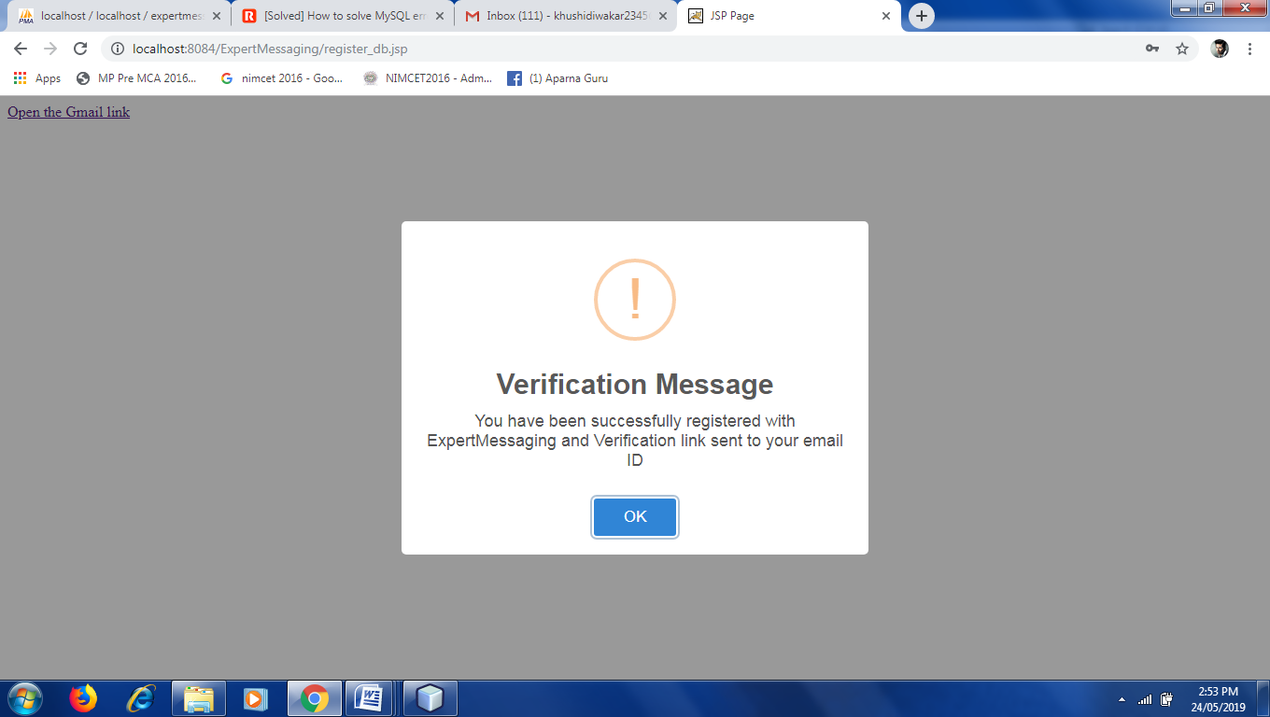

1. **Verify From Gmail –** This screen is display when we click on “Open the Gmail Link” then firstly you can login to gmail with your mail ID and password and then this screen is show. In this student can verify yourself with the help of email which is received from **“Institute management Site”**

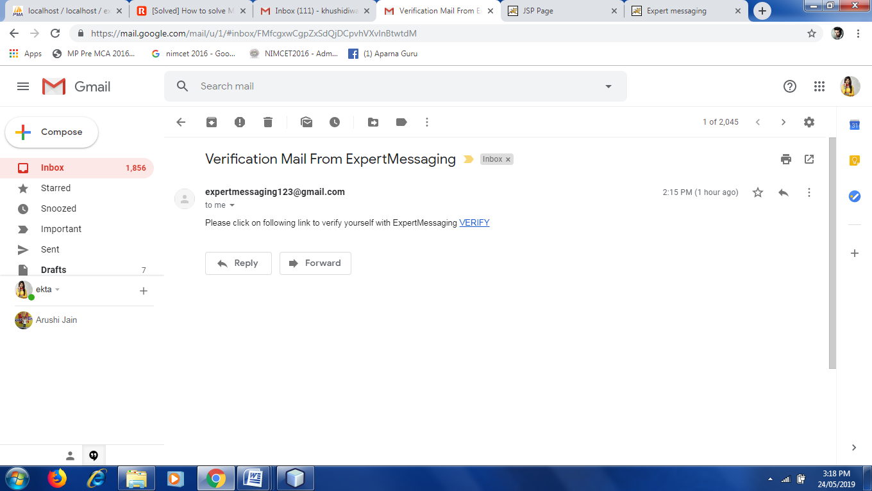

1. **Verification Message For Verify Your Account-** When Studentclicks on verify button on his/her mail then this message is show.

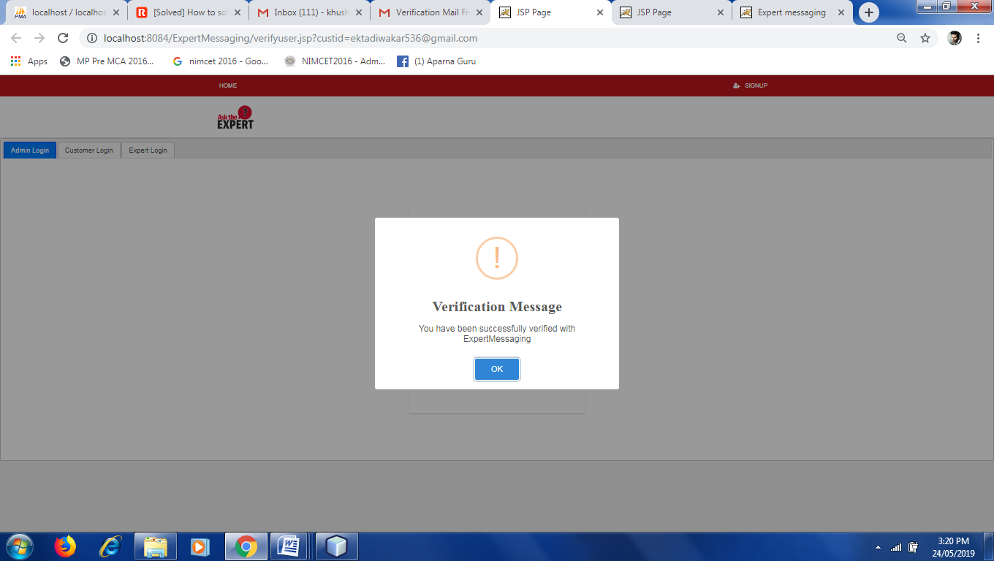

1. **Student Login Screen –** This screen is display when student is verifying by their mail, thenstudent has right to login and visit the website or performsgivenoperation.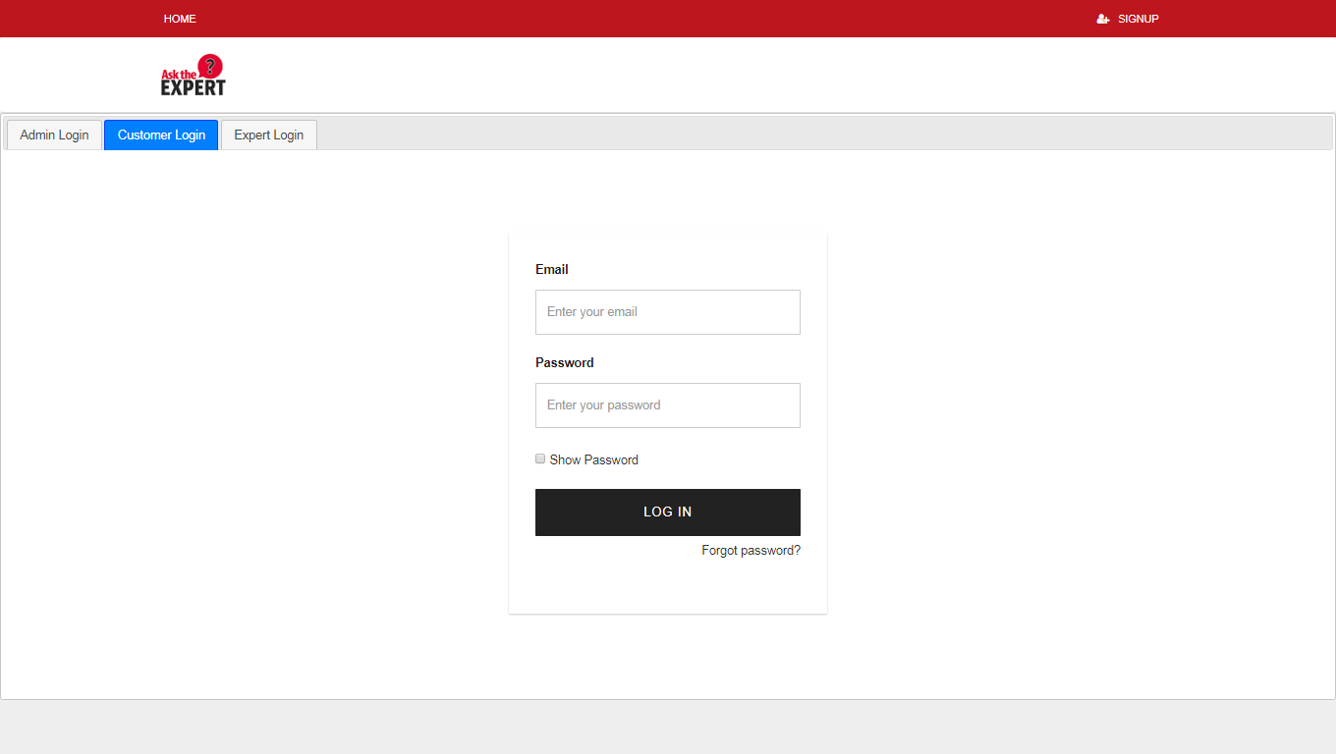
2. **Student Home**– Once student is login, then the home page is come for student in whom it show all tasks related with us like edit profile, ask a question to expert, incident raised for expert and also see an answer of its latest question.

In home page, there is “Search Bar” for student to search a question& answer related with all given category.There are 3 tabs are available as Unanswered Question, Answered Question, Incident Raised.

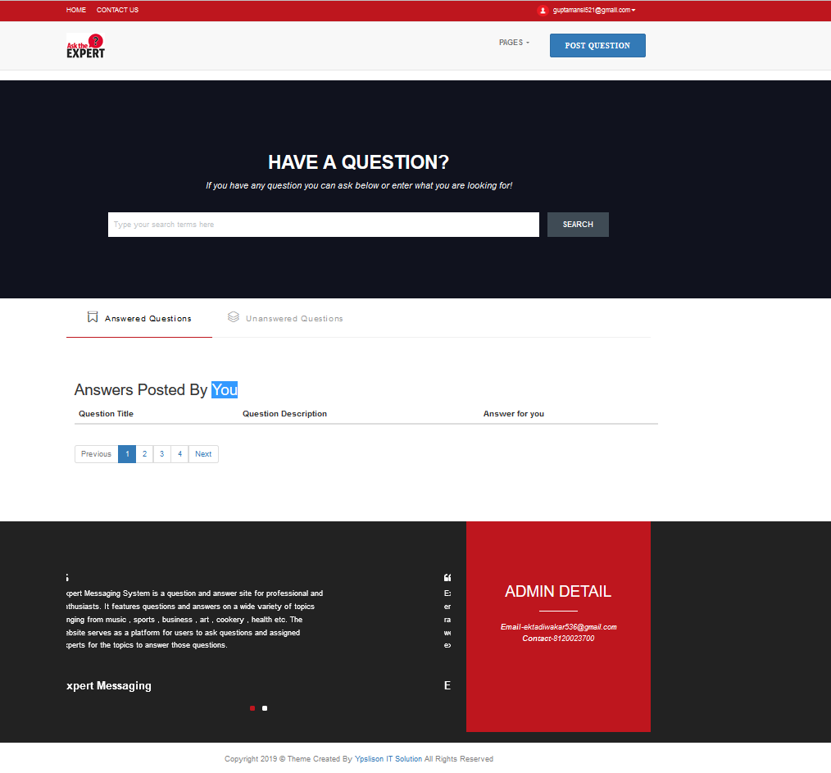

1. **Post Question Screen –** This screen is display when we click on “Post Question” button in home page. In this page, user can ask a question from selected category or sub-category and give them a title for question.It also contains a“visibility” checkbox for checking weather a question is public or private.By default it is public. When we fill all information related with question, then click on “Publish Your Question” button. After all verification message is show that “Your question will be posted successfully”.

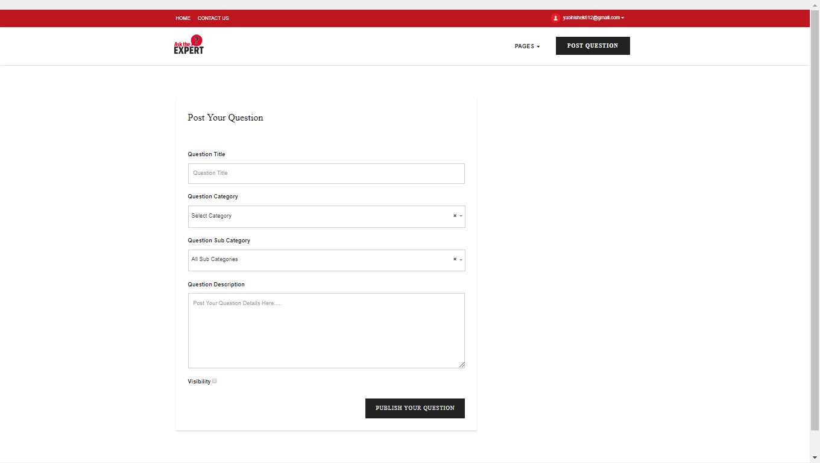

1. **Question Asked By AStudent –**This screen is display when student ask a question successfully then it also has a choice to see a list of question which is asked byus. There are 3 tabs available on this screen. In 2 tab all unanswered question list is show.

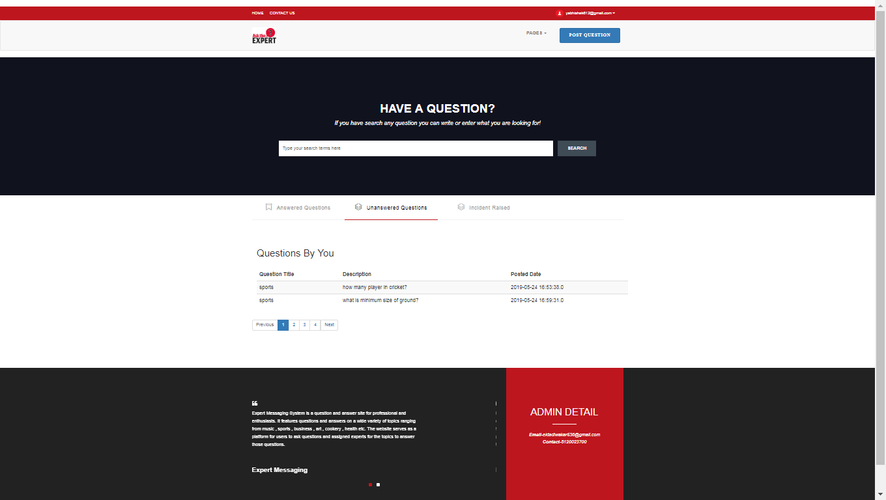

1. **Expert RegistrationScreen -**This screen is display when admin click on “Expert Registration” button in its home page. It fills all information related with expert like category, sub-category and then click on “Create Account” button.

**NOTE –** Expert can’t register itself, only admin can do this.

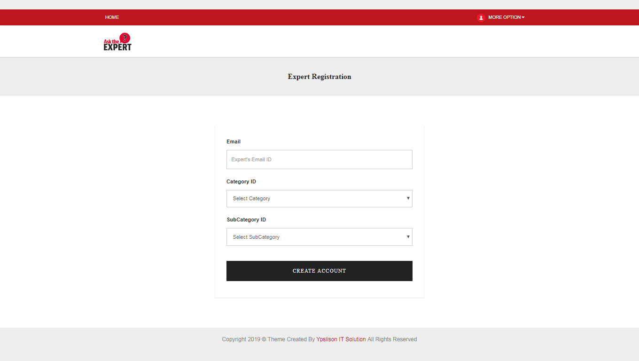

1. **Expert Login Screen -** This screen is display when expert click on “Login” button in main page, but it must have their id and password which is given by admin at the time of their registration.But if it doesn’t have their correct id and password then it cannot be login.

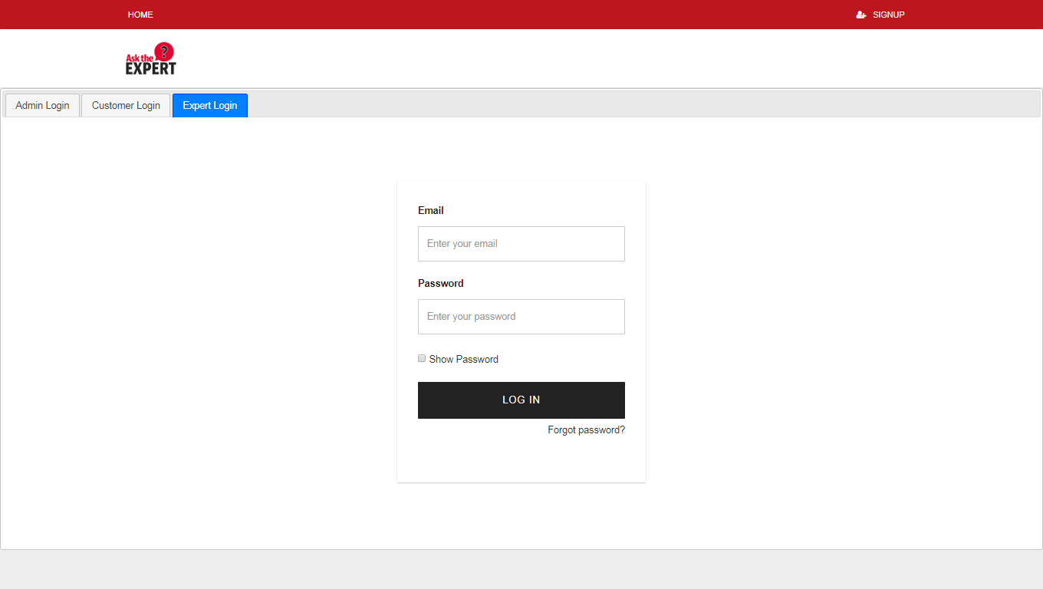

1. **Expert Home Screen –** Once expert is login, this screen is display which is a home pagefor expert in whom it can perform all tasks related with us like edit profile, answer a given question for student, also raised an incident for student when answer a question. There are 3 tabs are available as Unanswered Question, Answered Question, Incident Raised.

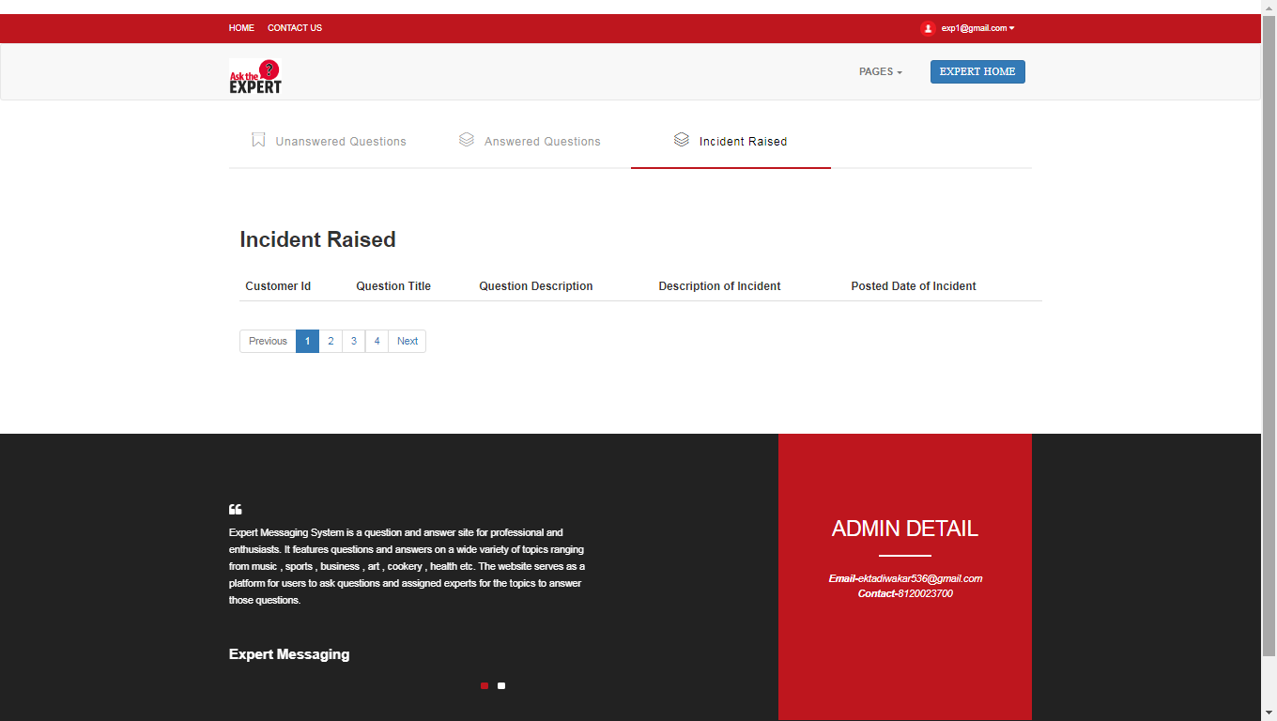

1. **Expert Answer A Question Screen –** This screen is display when expert click on “Unanswered Question” tab. In this tab expert can answer an given question which is asked by studentand that question whose answer is given by expert is remove from this tab and it show in another tab which is “Answered Question”.

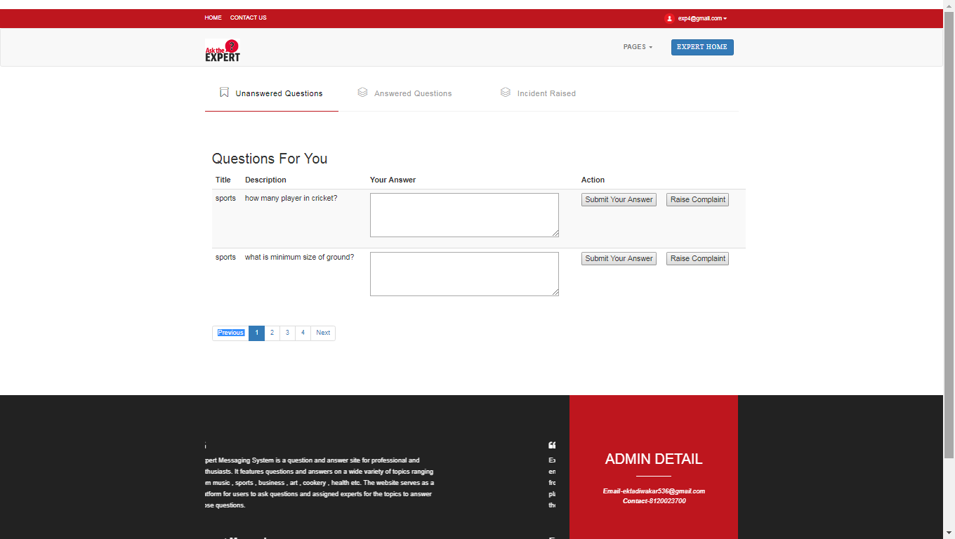

1. **Raise Complaint By Expert Screen –** This screen is display when expert answer a given question but something is not right like student misbehave or miscommunication between themetc, then expert click on “Raise Complaint”button then a dialog box is open in which expert write a complaint and click on “Post Complaint”button to raised a complaint for student to admin.

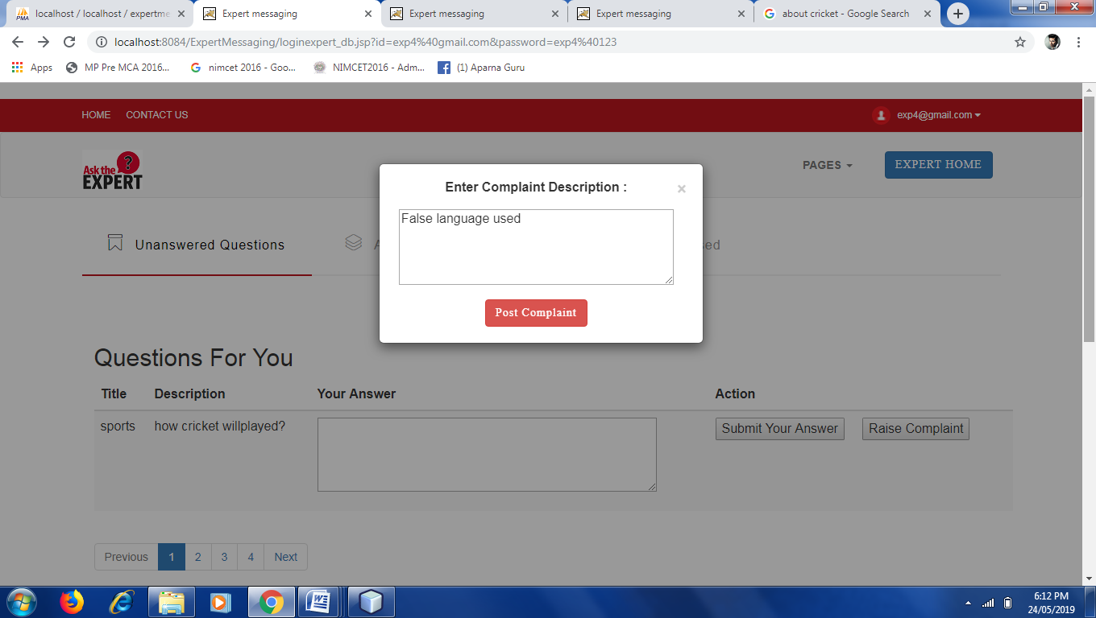

1. **Answer See By Student–**This screen is display when answer is submit by expert and that answer is seen by a student in a “Answered Question” tab of student and expert, also show a timing of answer given.

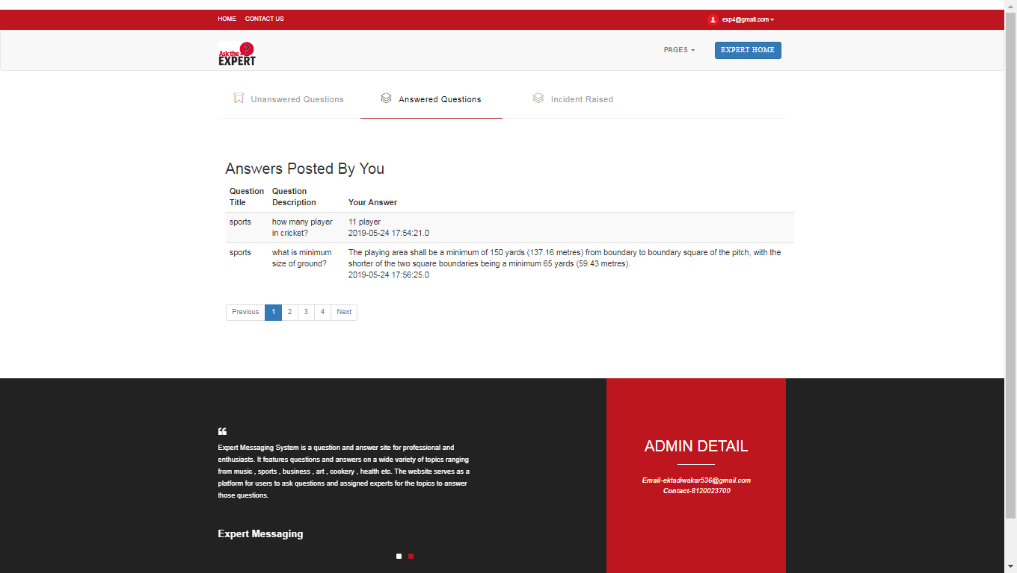

1. **Admin Login -** This screen is display when admin click on “Login” button in main page. Once admin login, it come to home page and can perform tasks related to it.

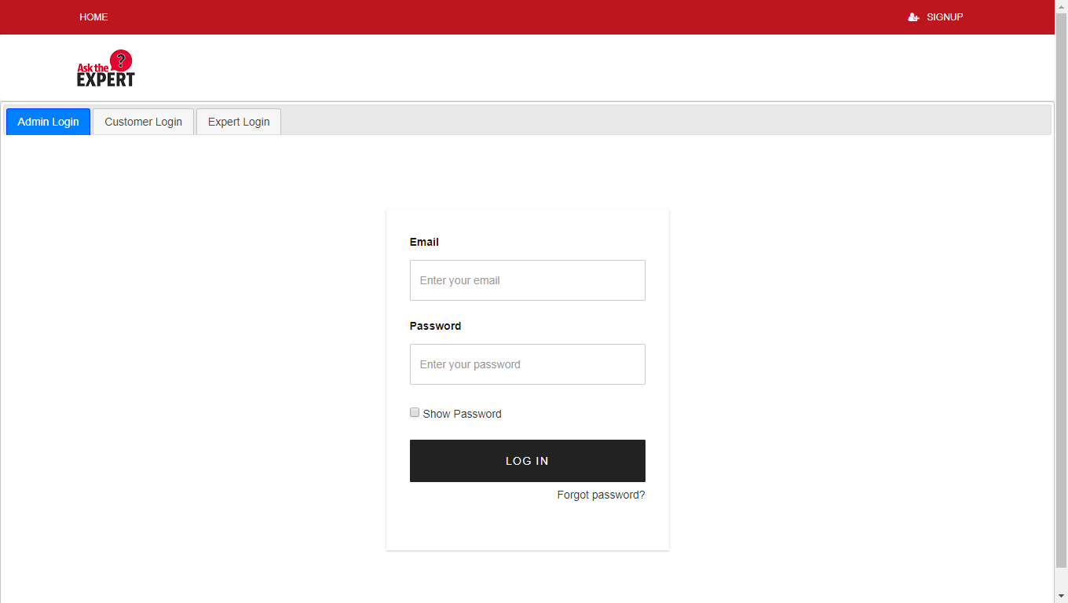

**ADMIN HOME**

In admin home page there is a “Search Bar” tab through which admin can see all question and answer. There are 4 tabs available as Show Student List, Show Expert List, Show All Expert Incidents and Show All Student Incidents.Also it can register an expert.

1. **Contact Us –** This screen is display when we click on “Contact Us” in main pages and home page of student& expert.

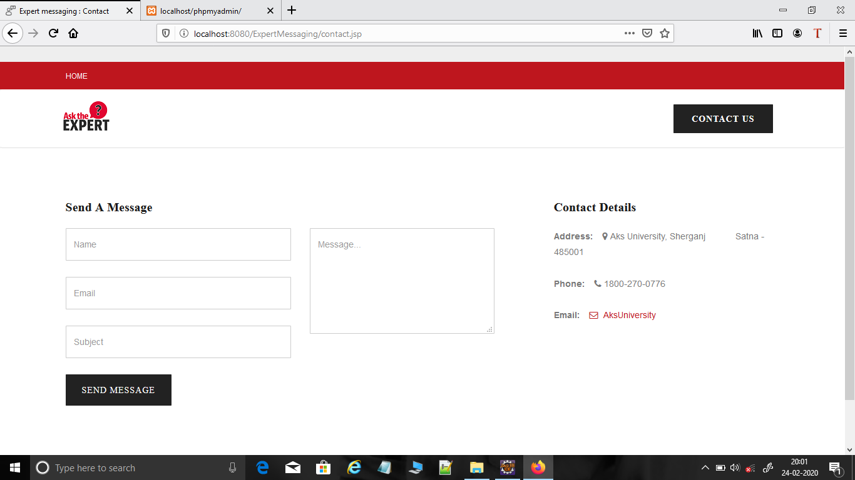

**CODING –**

**Front End:-** html , CSs , Bootsrap4 , javascript , jquery

**Back End:**JSp , MVC , MYSQL



**Testing**

1. Testing Objectives
2. Testing Methodology
3. Quality Attributes
4. Validation Checks
5. Characteristics of

language used

**1. TESTING OBJECTIVES**

The completion of a system is achieved only it has been thoughly tested. Thought this gives a feel the project is completed, there cannot be any project without going through this stage. Hence is this stage it is decided whether the project can undergo the real time environment execution without any break down, therefore a package can be rejected even at this stage.

The primary objectives of software testing are as follows:

1. Testing is a process of executing a program to find an error in it.
2. A good test case should have a high probability of finding an as-yet-undiscovered error.
3. A test case will be considered successful if it uncovers an as-yet-undiscovered error.
   1. **Testing Principles**

* All tests should be traceable to student requirements.
* Tests should be planned long before testing begins.
* The Pareto principle applies to software testing.
* Testing should begin "in the small" and progress towards testing "in the large".
* Exhaustive testing is not possible.

To be most effective, testing should be conducted by in independent third party.

**2. TESTING METHODOLOGIES**

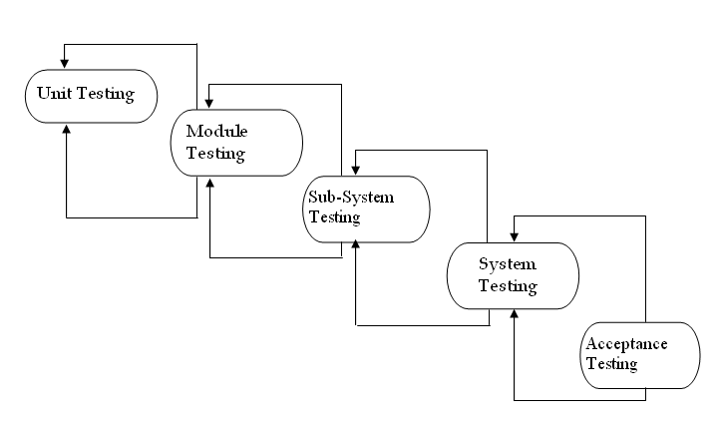

* **Unit Testing**

Unit testing aims the verification effort on the smallest unit of software design i.e., a software component or module. It uses procedural design as a guide to test major control paths and uncover errors within the module boundary. It is white box oriented and the step can be conducted in parallel for multiple components.

Unit testing is a dynamic method for verification, where the program is actually compiled and executed. It is one of the most widely used methods, and the coding phase is sometimes called “coding and unit testing phase”. The goal of unit testing is to test modules or “units”, not the whole software system. Unit testing is most often done by the programmer himself/herself. The goal of unit testing is to isolate each part of the program and show that the individual parts are correct. A unit test provides a strict, written contract that the piece of code must satisfy. As a result, it affords several benefits.

* **Integration Testing:-**

Integration testing is a phase of software testing in which individual software modules are combined and tested as a group. It follows unit testing and precedes system testing. The major objective of integration testing is to tackle the problem of interfacing i.e. putting all the acceptable imprecision (view) may be magnified to unacceptable levels; global data structure can cause problems and to truncate this list of problems we use integration testing.

Integration testing is a systematic technique for constructing the program structure while at the same time conducting tests to uncover errors associated with interfacing. The objective is to take unit tested components and build a program structure that has been dictated by the design.

Integration testing strategy used is Bottom-Up Integration Testing. In it all the bottom or low level modules, procedures or functions are integrated and then tested. After the integration testing of lower level integrated modules, the next level of modules will be formed and can be used for integration testing. This approach is helpful only when all or most of the modules of the same development level are ready. This method also helps to determine the levels of software developed and makes it easier to report testing progress in the form of a percentage.

* **Validation Testing**

At the climax of integration testing, software is developed as a package having all the errors uncovered and corrected. At this time, a final series of software test may begin. It is called validation testing. Validation succeeds when software functions in a reasonably expectable manner. Validation attempts to uncover errors, but the emphasis is on the requirement level i.e. the things that will be immediately apparent to the student.

A major element of the validation process is a configuration review, which is conducted to ensure that all software configuration elements have been well developed, well-cataloged, and have the essential detail to bolster the support phase of the software life cycle.

**3. QUALITY ATTRIBUTES**

Quality attributes are the overall factors that affect run-time behaviour, system design, and user experience. They represent areas of concern that have the potential for application wide impact across layers and tiers. Some of these attributes are related to the overall system design, while others are specific to run time, design time, or user centric issues. The extent to which the application possesses a desired combination of quality attributes such as usability, performance, reliability, and security indicates the success of the design and the overall quality of the software application.

**Common Quality Attributes**

1. Conceptual Integrity:- Conceptual integrity defines the consistency and coherence of the overall design.
2. Maintainability:- Maintainability is the ability of the system to undergo changes with a degree of ease.
3. Reusability:- Reusability defines the capability for components and subsystems to be suitable for use in other applications and in other scenarios.
4. Availability:- Availability defines the proportion of time that the system is functional and working. It can be measured as a percentage of the total system downtime over a predefined period.
5. Inter compatibility:- Interoperability is the ability of a system or different systems to operate successfully by communicating and exchanging information with other external systems.
6. Manageability:- Manageability defines how easy it is for system administrators to manage the application, usually through sufficient and useful instrumentation.
7. Performance:- Performance is an indication of the responsiveness of a system to execute any action within a given time interval.
8. Security:- Security is the capability of a system to prevent malicious or accidental actions outside of the designed usage, and to prevent disclosure or loss of information.

A crucial phase in the system life cycle is the successful implementation of the new system design. Implementation simply means converting a new system design into operation. This involves creating computer compatible files, training the operating staff and installing hardware terminals, and telecommunication network before the system is up and running.

In system implementation, user training is crucial for minimizing resistance to change and giving the new system a chance to prove its worth. Training aids such as user-friendly manuals, a data dictionary and job performance aids that communicate information about the new system and help screens. Provide the user with a good start on the new system.

1. **VALIDATION CHECKS**

A major element of the validation process is a configuration review, which is conducted to ensure that all software configuration elements have been well developed, well-cataloged, and have the essential detail to bolster the support phase of the software life cycle.

In this system we use a login user name and password as validation checks and marks some checks for user information like phone number only in ten digits, all fields are required , password contain at least 6 character etc.

It has been a great pleasure for me to work on this exciting and challenging project. This project proved good for me as it provided practical knowledge of not only programming in Java web based application and no some extent Windows Application and SQL Server, but also about all handling procedure related with “Institute management Site”. It also provides knowledge about the latest technology used in developing web enabled application and client server technology that will be great demand in future. This will provide better opportunities and guidance in future in developing projects independently.

1. **CHARACTERISTICS OF LANGUAGE USED**

There were five primary characteristics in the creation of the Java language:

1. It should be "simple, object-oriented and familiar".
2. It should be "robust and secure".
3. It should be "portable".
4. It should execute with "high performance".
5. It should be "interpreted, threaded, and dynamic".



**conclusion &**

**discussion**

1. Limitations
2. Difficulties Encountered
3. Future Enhancement
4. Conclusion

**1. LIMITATION**

* + Student cannot visit the website without register yourself.
  + It handle only limited user in the current version.
* Answers given by expert are little bit slower.
* We cannot complete rely on the answers given by expert.
* The size of the database increases day-by-day, increasing the load on the database back up and data maintenance activity.
* Training for simple computer operations is necessary for the users working on the system.

**2. DIFFICULTIES ENCOUNTERED**

* + Expert only know the answer , which is related to there Category.
  + Admin can block the student and expert.
  + Once the student is block by the admin they could not ask the question and also expert is block they don’t give the answer of question.
  + Student and expert both report any incident.

**3. FUTURE ENHANCEMENT**

* In future chat option with the student on a paid basis.
* Discussion option for the question on a paid basic.
* Rating option.

**4. CONCULSION**

In this student can register him/her self. After that student login then visit the site. Student can reply to the answers given by Expert and further discussion can be doneStudent will have options change password, forgot password, delete profile in the Profile ViewStudent will be given Search Bar to search for questions based on topicsStudent can control whether questions asked by him/her will be shown to other users of the website. (Private / Public Question) . Expert will be provided Login ID and Password by the Admin of the websiteOnce logged in, Expert will be shown the list of questions asked in the category he/she is assigned toExpert will provide his/her comments on the asked questionOnce the question is answered, Expert will have the option to close the questionIn Profile View, Expert will have options change password, forgot password. Admin once logged in, will have options to Add , Edit , Delete categories of questionsAdmin is given responsibility to provide login-id and password and categories for ExpertsAdmin can block Students and Experts based on reported incidentsAdmin can view list of all questions asked by Students and answers provided by Experts as per categoriesAdmin can view list of all Students and Experts registered with the website.



**Bibliography &**

**References**

1. Reference Books
2. Reference Websites

**1. REFERENCE BOOKS**

1. Naughton and Schildt (1999): “The Complete Reference Java 2”, Tata McGraw Hill 1999.

2. Deitel (2004): *"Java How to Program"*, Fifth Edition. *Pearson Education*, 2004.

3. Ullman (2008): "Analysis and Design of Algorithm", McGrawhill,New York, 2008.

4. Goodman (2002): “Introduction to the Design & Analysis of Algorithms”, TMH-2002.

5. Elmarsi (2004): “Fundamentals of Database Systems”, 6thEdition, Pearson Education, 2004.

6. R. Ramakrishnan (1998): “Database Management Systems”, McGraw Hill, International Editions, 1998.

**2. REFERENCE WEBSITES**

1. https://www.javatpoint.com/MVC-in-jsp

2. https://www.w3schools.com/html/html_form_attributes.asp

3. https://www.w3schools.com/bootstrap/bootstrap_ver.asp

4. https://www.w3schools.com/js/js_events_examples.asp

5. https://stackoverflow.com/questions/6640089/what-causes-this-jsp-error-500

6. https://www.developer.com/java/creating-a-jdbc-gui-application.html

7. https://www.javatpoint.com/example-of-sending-email-using-java-mail-api-through-gmail-server

8. https://stackoverflow.com/questions/15630771/check-table-exist-or-not-before-create-it-in-oracle?utm_medium=organic&utm_source=google_rich_qa&utm_campaign=google_rich_qa